**Cacti Installation Manual**

DOCUMENT VERSION HISTORY

|  |  |  |  |
| --- | --- | --- | --- |
| VERSION | DATE | DESCRIPTION | AUTHOR/EDITOR |
| 0.90 | 1/17/2024 | 1st. version | Autumn.Shi, Harry.Chen  HongQing, Lei.Liu Double.Lin |
| 0.94 | 10/2/2024 | Add Netflow configuration | Spencer |

Contents

1 Platform Installation 2

1.1 VM Spec 2

1.2 Install OS 2

2 Cacti Installation 8

2.1 Install Apache (Web Server) 8

2.2 Install MariaDB (DB Server) 9

2.3 Install Cacti 11

2.4 Configure Cacti DB 12

2.5 Configure Cacti 13

2.6 Install & Configure Spine 14

2.7 Generate self-signed CA, 10 years, Disable tls1.x 17

2.8 Enable http compression 18

2.9 Disable firewall 20

2.10 (Optional) Enable firewall port: http https snmp 20

2.11 Install & Configure NTP 20

3 Cacti Configuration 22

3.1 Pre-Installation Check 22

3.2 Configure Cacti 31

3.3 Install Plug-in 35

3.4 Enable thold as a service 36

3.5 Enable 1 minute data collection and keep 1 month & 1Year 37

3.6 Import Monitor Template – Win Service & TCP Port & Linux process 40

3.7 Improve data collection performance 44

3.8 (Optional) Install Chinese language pack 44

4 Add Cacti into Monitor 46

4.1 Configure SNMP 46

4.2 Configure Cacti Service to monitor 47

4.3 Add Cacti device 48

5 Enable syslogs plugin 49

6 Enable flowview plugin 55

6.1 Create a dedicated disk partition 200GB for flowview DB 55

6.2 Create a dedicated DB for flowview 57

6.3 Flowview install & configure 58

6.4 Configure flowview generator simulator 65

6.5 Configure listeners 67

6.6 Configure filters 68

**6.7** **Configure listeners** 69

**6.8** **Configure filters** 70

**6.9** **Statistical Report** 71

**6.10** **Check DB size & Row numbers** 71

**6.11** **Sample flow export configuration on Cisco SW & Fortigate** 72

# Platform Installation

## VM Spec

#CPU 8 core, RAM 8G, HD 100G.

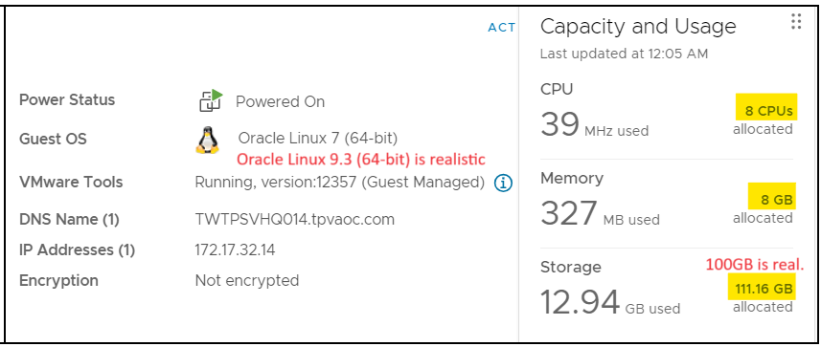

## Install OS

#Linux ISO: Oracle Linux 9.3 is fully supported by this manual.

OracleLinux-R9-U3-x86_64-boot.iso (minimal version, 930MB)

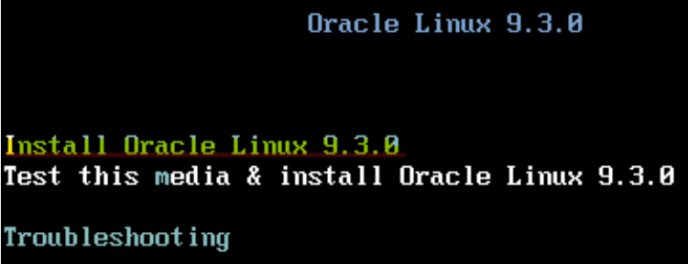

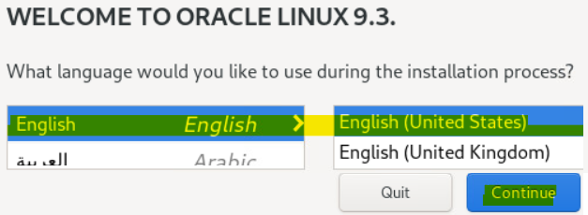

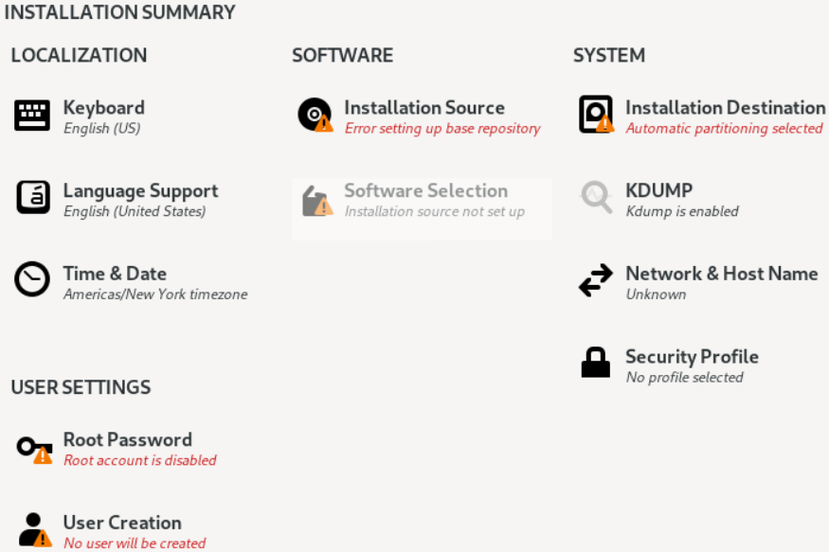  
  
Select your time zone

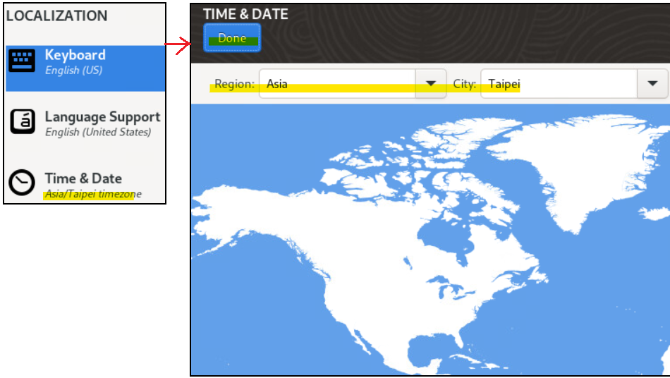

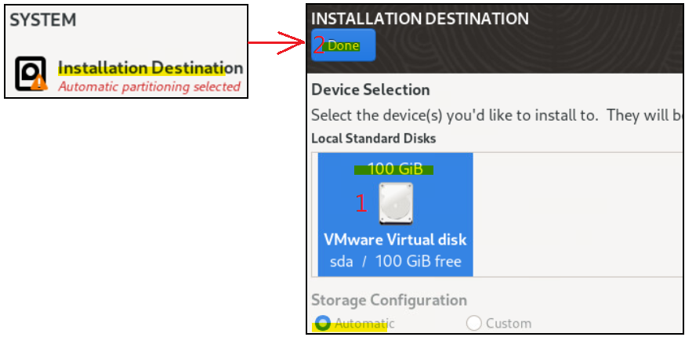

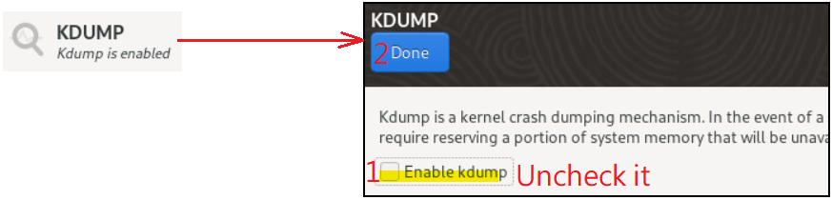

1.Type Host Name =>2.Apply =>3 Check =>4 Click Configure

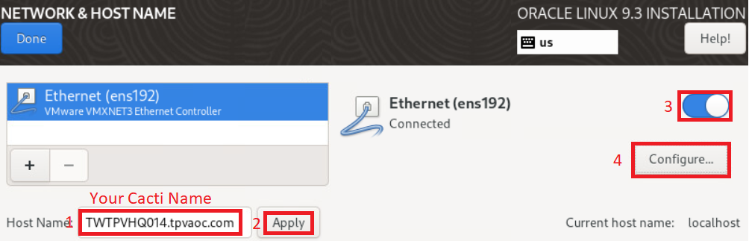

Click IPV6 setting => Select Method “Disabled”

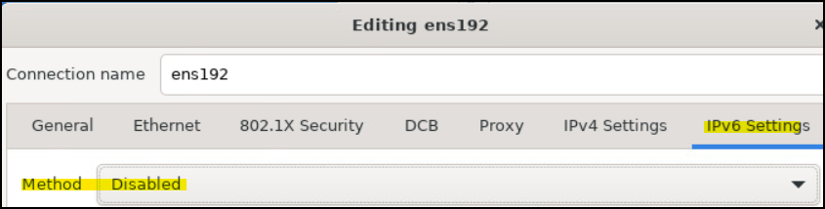

Click IPv4 Settings => Manual => Type Address IP, DNS IP, Search Domain tpvaoc.com => Click Save.

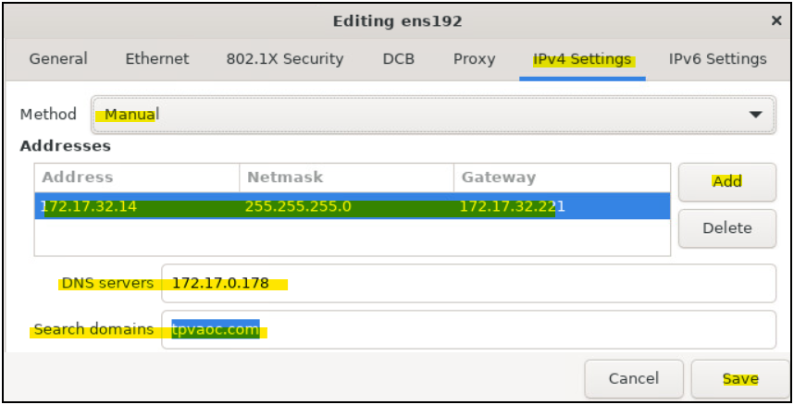

Verify network is “Connected” => Click Done.

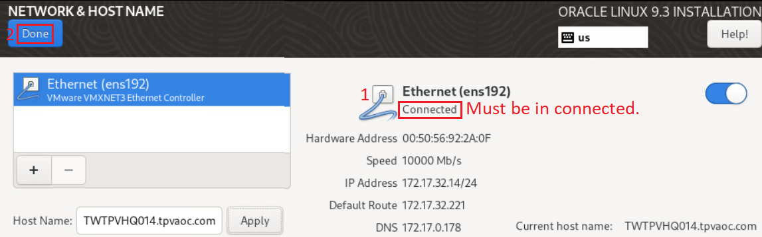

Click Software => Installation Source => Click “On the network” => Done

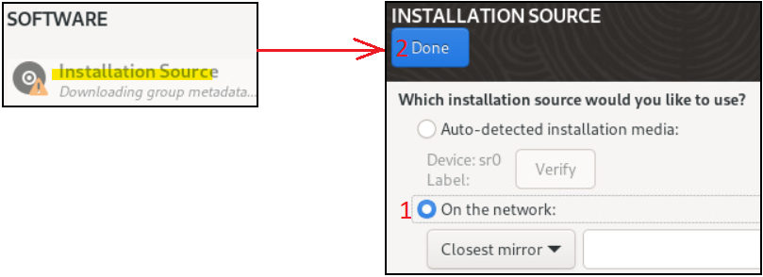

Click “SW selection” => Just select “Minimal Install”

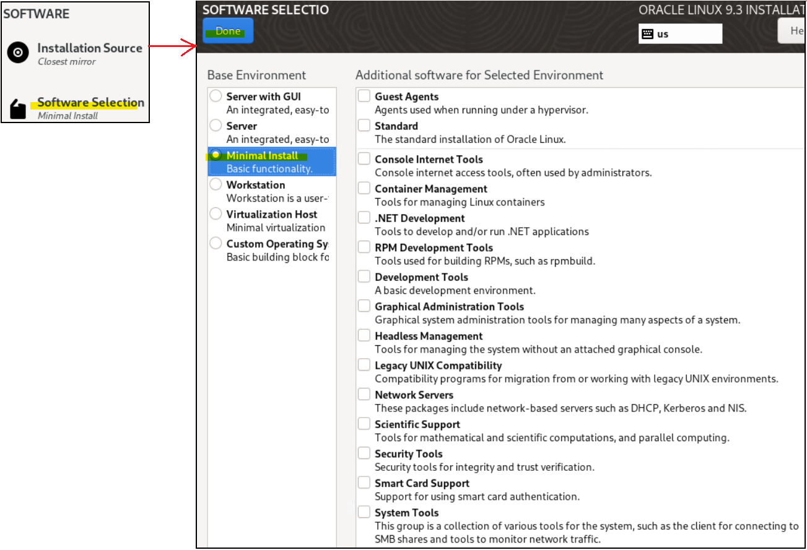

Set root Password => Unlock root account => Allow SSH

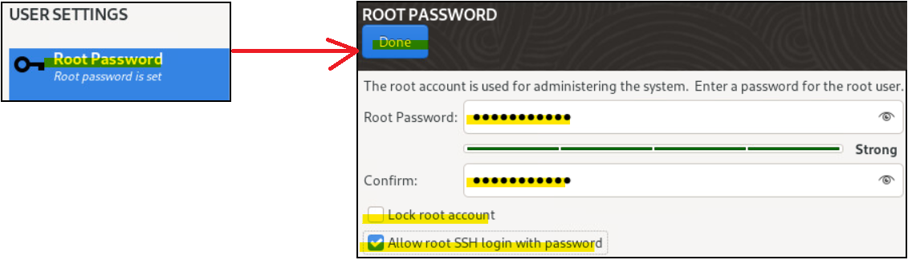

Confirmed 7 yellow marked is matched to your situation

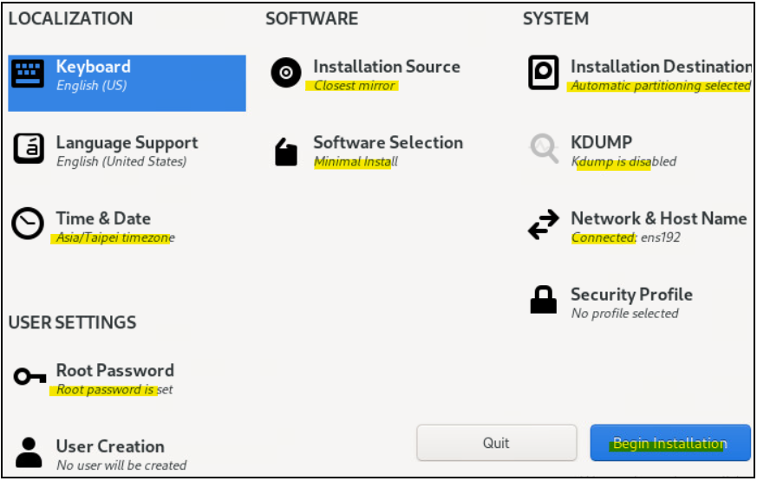

Start installation  
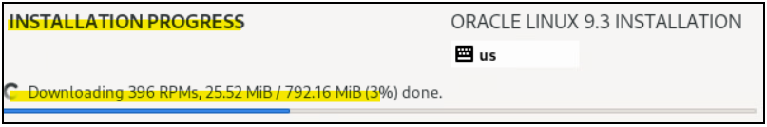  
Reboot

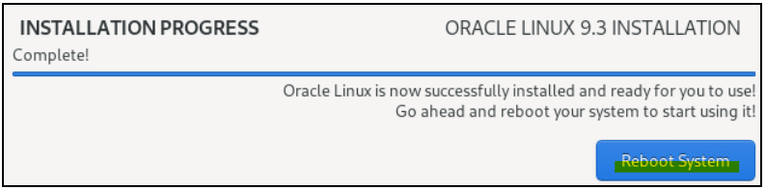

#update patch to newest

yum -y update

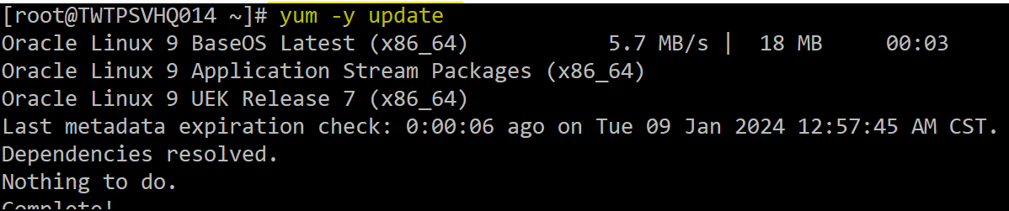

# Cacti Installation

## Install Apache (Web Server)

#Enable Epel repo to enable PHP 7.2 package download

yum install -y http://rpms.remirepo.net/enterprise/remi-release-7.rpm

yum install -y yum-utils

yum-config-manager --enable remi-php72

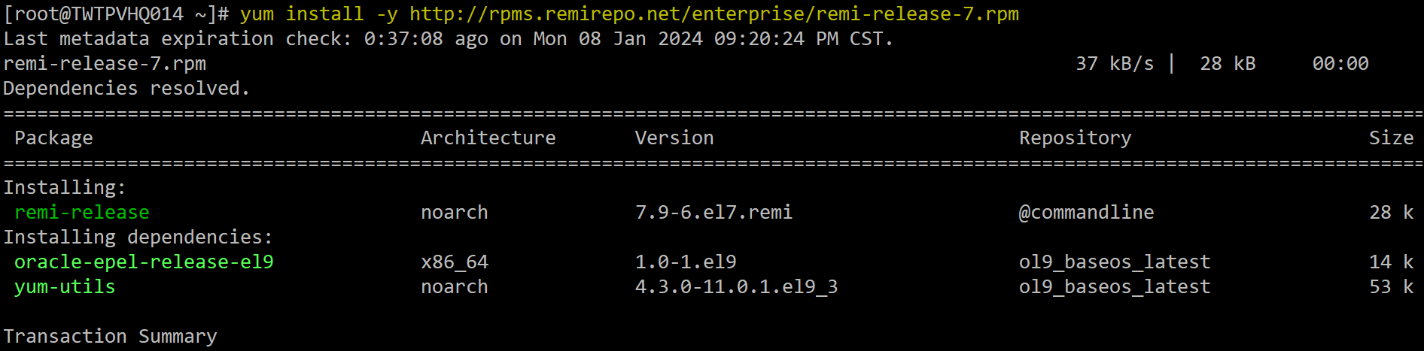

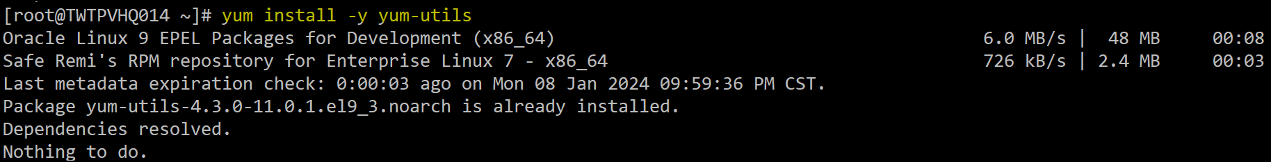



#Linux OS patch update to newest

yum -y update

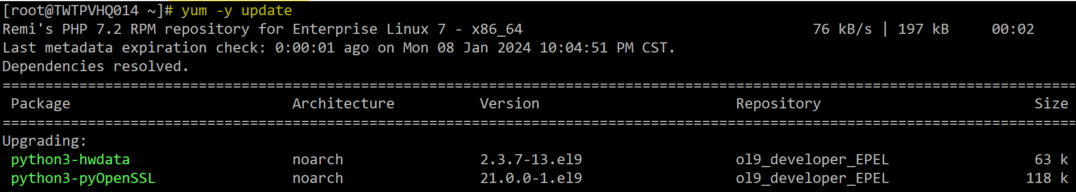

# Install Apache

yum install -y httpd

systemctl enable httpd

systemctl start httpd

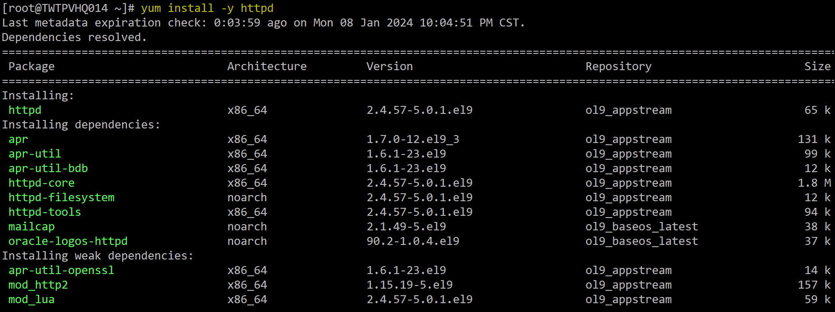



## Install MariaDB (DB Server)

dnf install -y mariadb-server

systemctl enable mariadb

systemctl start mariadb

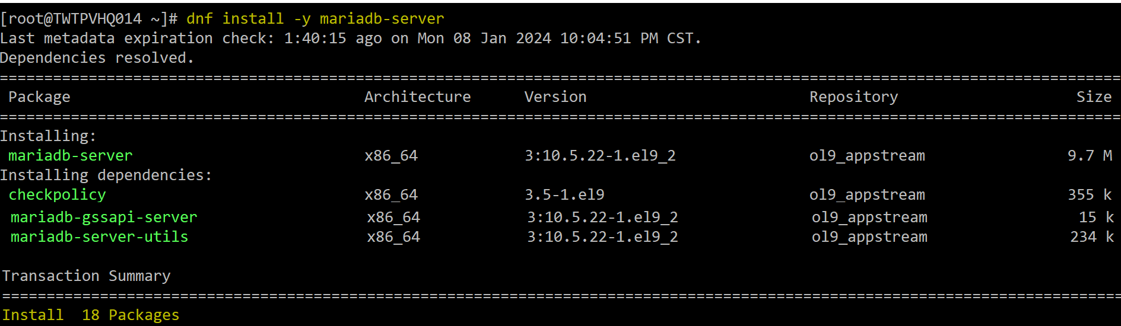



# IMPORTANT: Secure your MySQL installation before doing any more changes

/usr/bin/mysql_secure_installation

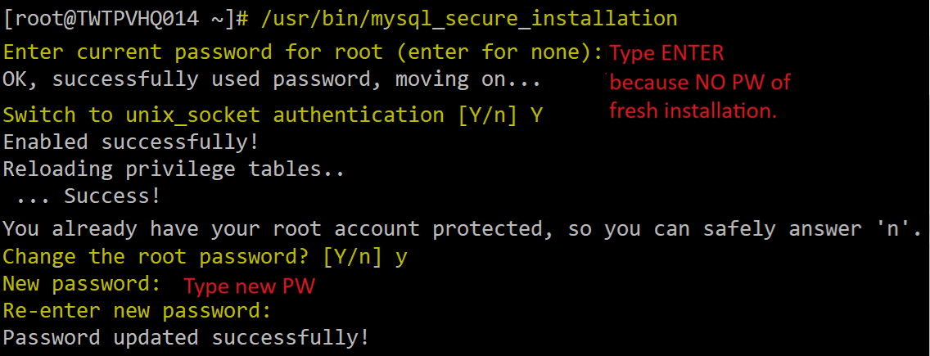

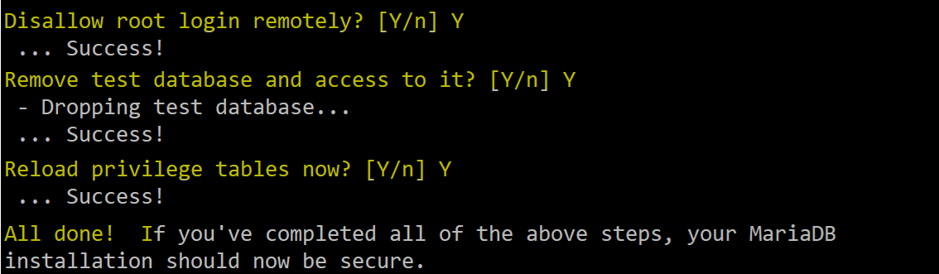

# he following MySQL/MariaDB recommendations may vary depending on your system setup. In any case, Cacti will prompt you with more accurate recommendations during the installation

Copy to /etc/my.cnf.d/

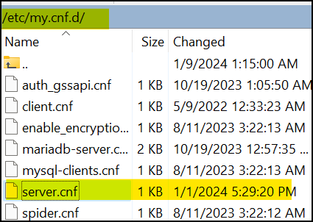

Content of nano /etc/my.cnf.d/server.cnf as below

[mysqld]

character-set-server=utf8mb4

collation-server=utf8mb4_unicode_ci

innodb_file_format = Barracuda

max_allowed_packet = 16777777

join_buffer_size = 32M

innodb_file_per_table = ON

innodb_large_prefix = 1

innodb_buffer_pool_size = 250M

#innodb_additional_mem_pool_size = 90M

innodb_flush_log_at_trx_commit = 2

#log-error = /var/log/mariadb/mysql-error.log

log-queries-not-using-indexes = 1

slow-query-log = 0

#slow-query-log-file = /var/log/mariadb/mysql-slow.log

max_heap_table_size = 124M

tmp_table_size = 124M

innodb_buffer_pool_size = 2000M

innodb_doublewrite = ON

innodb_flush_log_at_timeout = 3

innodb_read_io_threads = 32

innodb_write_io_threads = 16

innodb_io_capacity = 5000

innodb_io_capacity_max = 10000

systemctl restart mariadb



## Install Cacti

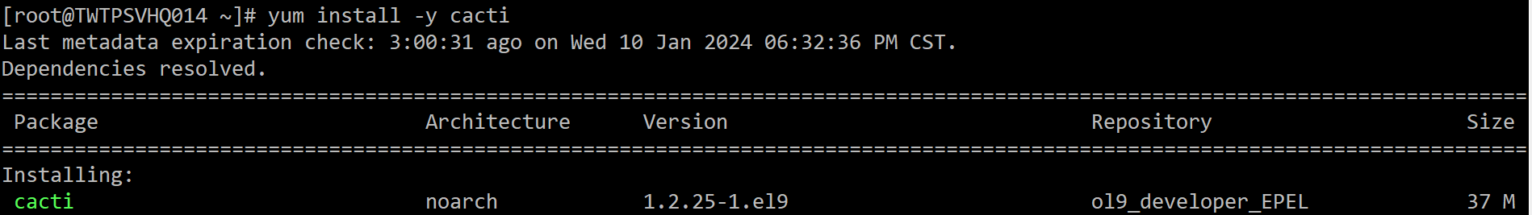yum install -y cacti

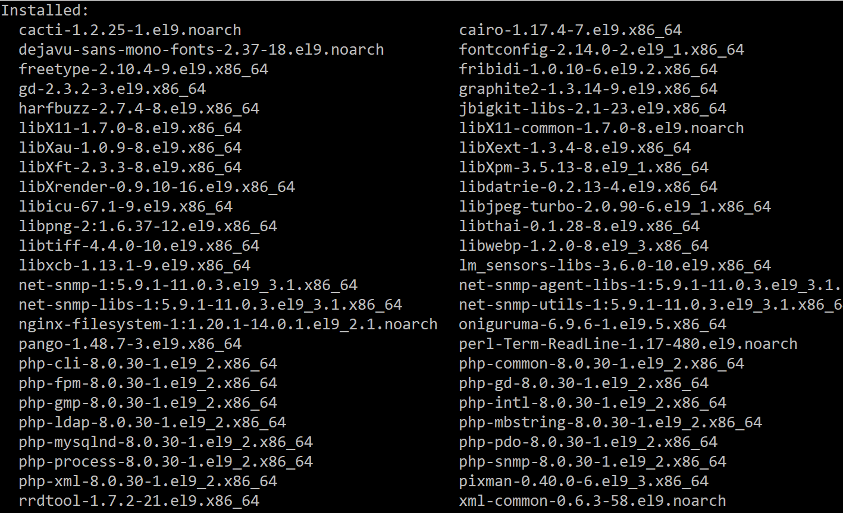

## Configure Cacti DB

mysql -u root -p c@Ct1Vser

create database if not exists cacti;

use cacti;

source /usr/share/doc/cacti/cacti.sql

quit

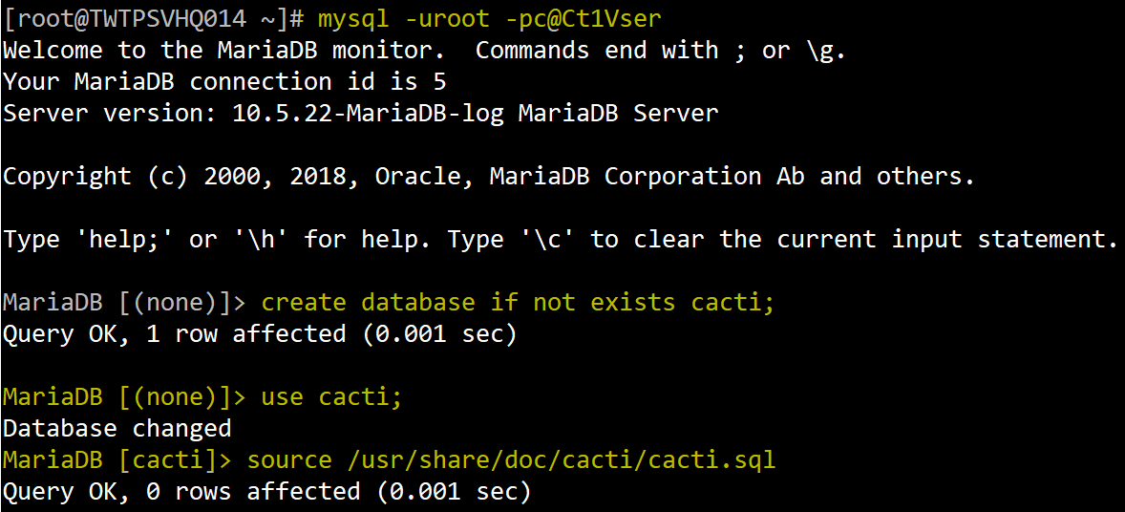

# Grant Cacti username access to Cacti database.

mysql -uroot -pc@Ct1Vser

CREATE USER 'cactiuser'@'localhost' IDENTIFIED BY 'c@Ct1Vser';

GRANT ALL PRIVILEGES ON cacti.* TO 'cactiuser'@'localhost’;

GRANT SELECT ON mysql.time_zone_name TO 'cactiuser'@'localhost';

FLUSH PRIVILEGES;

exit

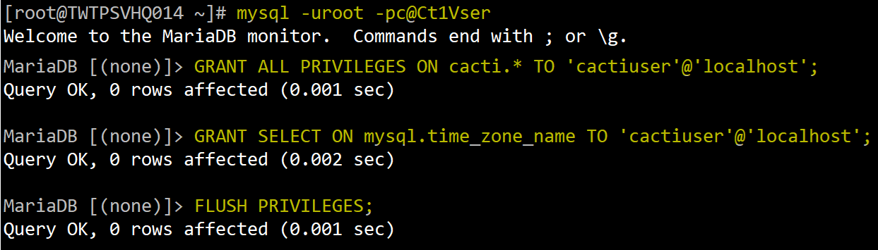

## Configure Cacti

#Install some tools

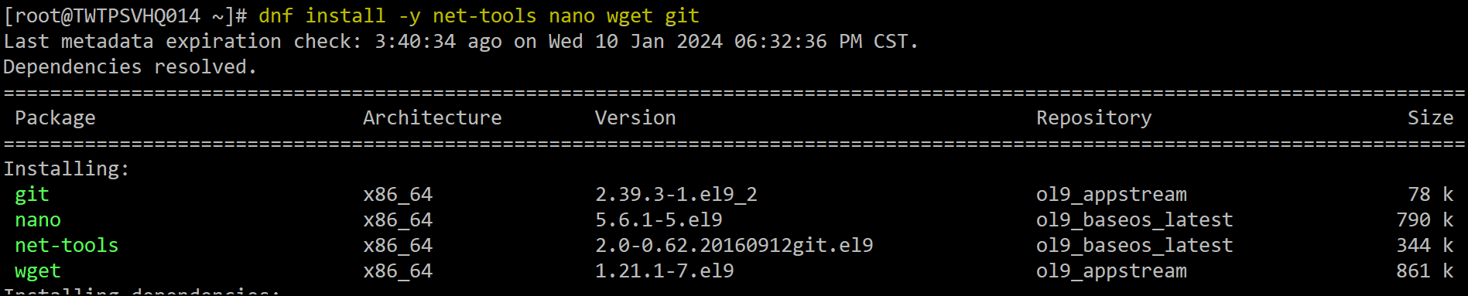dnf install -y net-tools nano wget git hping3



#Edit /etc/php.ini to replace with your time zone

nano /etc/php.ini

date.timezone = Asis/Taipei #replace with your time zone.

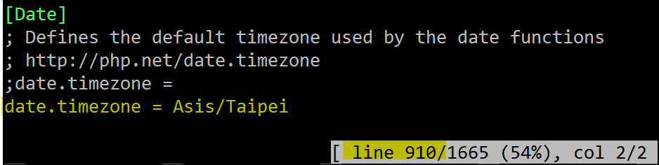

# Edit the config.php file, replace PW

nano /usr/share/cacti/include/config.php

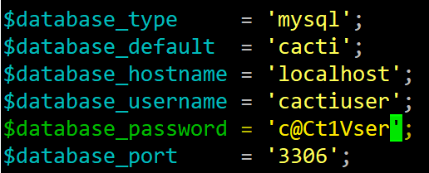

# Create your cron task file

nano /etc/cron.d/cacti # remove #



## Install & Configure Spine

# Install the necessary packages to compile and install spine

dnf --enablerepo=ol9_codeready_builder install mariadb-devel

dnf --enablerepo=ol9_codeready_builder install help2man

yum install -y net-snmp-devel

yum install -y autoconf automake libtool dos2unix openssl-devel



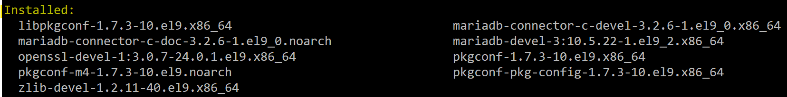





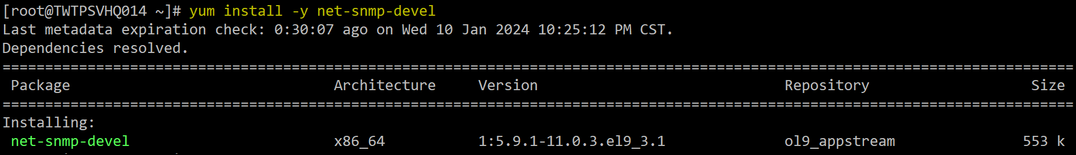

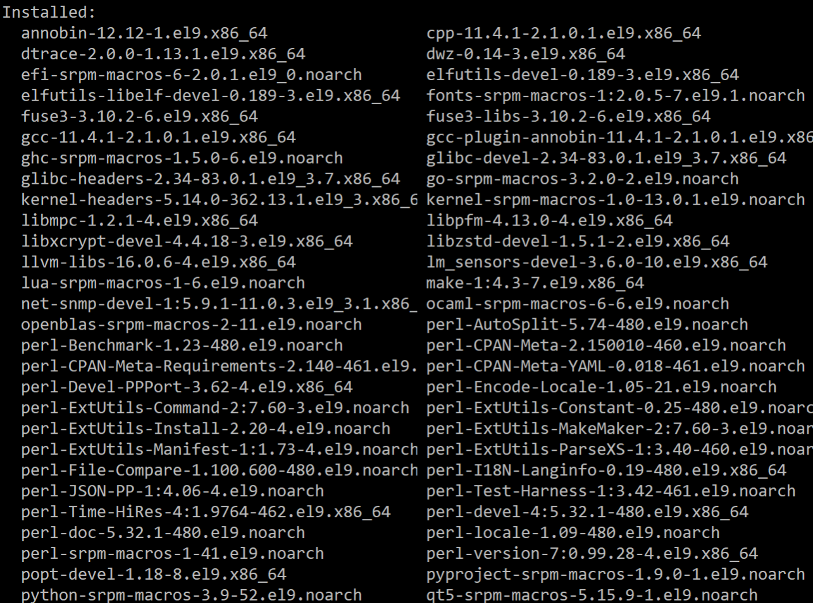





# Download spine source code from Cacti Web Site

cd /tmp

wget https://www.cacti.net/downloads/spine/cacti-spine-1.2.25.tar.gz

tar -zxvf cacti-spine-1.2.25.tar.gz

cd cacti-spine-1.2.25

# Run the configure script and compile spine.

sh

./bootstrap

./configure

make

make install

chown root:root /usr/local/spine/bin/spine

chmod +s /usr/local/spine/bin/spine

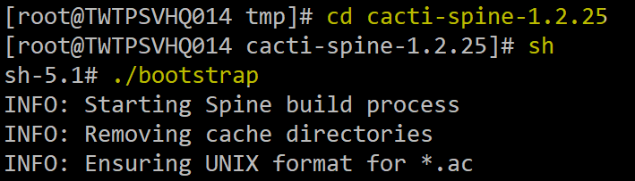  
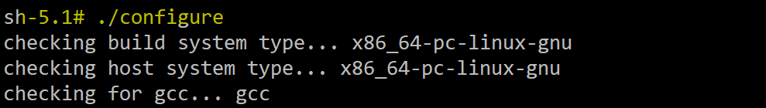

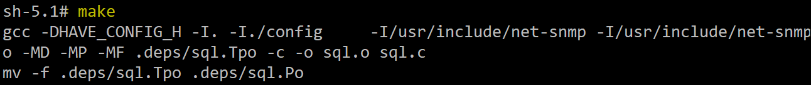

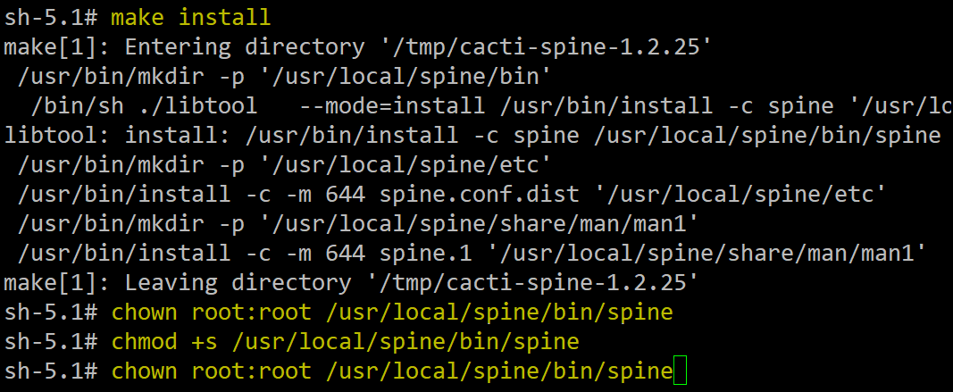

# Edit spine.conf

cp /usr/local/spine/etc/spine.conf.dist /usr/local/spine/etc/spine.conf

nano /usr/local/spine/etc/spine.conf

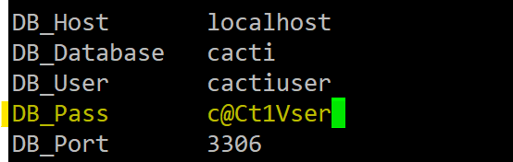

# Enable cacti as a service

cp /usr/share/cacti/service/cactid.service /usr/lib/systemd/system/

nano /usr/lib/systemd/system/cactid.service

touch /etc/sysconfig/cactid

nano /etc/cron.d/cacti

systemctl enable cactid

systemctl daemon-reload

systemctl start cactid

systemctl status cactid

## Generate self-signed CA, 10 years, Disable tls1.x

mkdir /etc/ca

openssl req -x509 -nodes -days 3650 -newkey rsa:2048 -keyout /etc/ca/cacti.key -out /etc/ca/cacti.crt

ls -lh /etc/ca



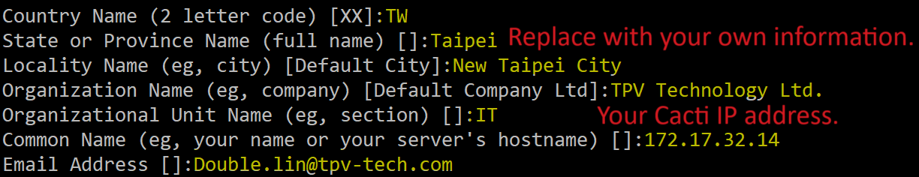

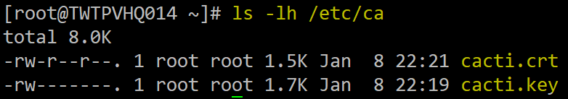

#Install mod_ssl, net-tools, nano, wget & git tools

yum install -y mod_ssl net-tools nano wget git

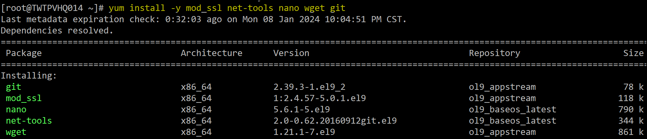

# Configure ssl.conf after backup

cp /etc/httpd/conf.d/ssl.conf /etc/httpd/conf.d/ssl.conf.bak

(Option)Duplicate /etc/httpd/conf.d/ssl.conf via WinSCP

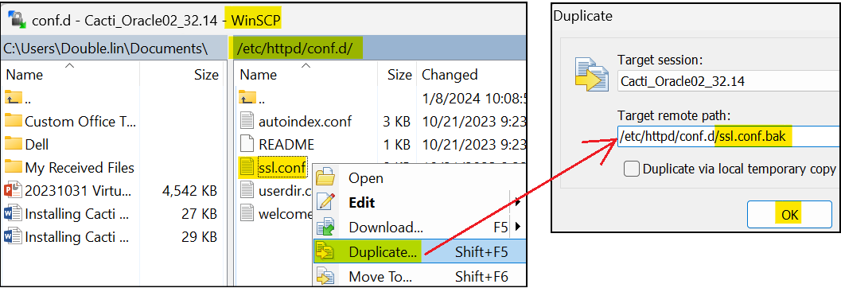

# new add lines to disable TLS v1.x & CA path, add (#) on the 2 original .crt &.key path

SSLProtocol all -SSLv3 -TLSv1 -TLSv1.1

SSLCertificateFile /etc/ca/cacti.crt

SSLCertificateKeyFile /etc/ca/cacti.key

#SSLCertificateFile /etc/pki/tls/certs/localhost.crt

#SSLCertificateKeyFile /etc/pki/tls/private/localhost.key

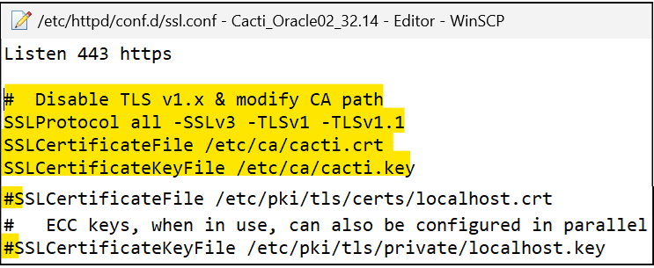

#Edit /etc/httpd/conf.d/cacti.conf after backup by cp or winscp

nano /etc/httpd/conf.d/cacti.conf

<Directory /usr/share/cacti/>

<IfModule mod_authz_core.c>

# httpd 2.4

#Require host localhost

Require all granted

</IfModule>

<IfModule !mod_authz_core.c>

# httpd 2.2

#Order deny,allow

#Deny from all

#Allow from localhost

Order allow,deny

Allow from all

</IfModule>

systemctl restart httpd

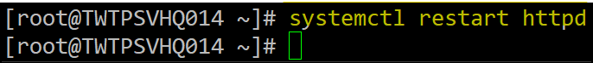

## Enable http compression

cp /etc/httpd/conf/httpd.conf /etc/httpd/conf/httpd.conf.bak

nano /etc/httpd/conf/httpd.conf

# Enable GZIP compression

LoadModule deflate_module modules/mod_deflate.so

#

# add the MIME (Multipurpose Internet Mail Extensions) types which

# you want the server to compress

<IfModule mod_deflate.c>

AddOutputFilterByType DEFLATE application/javascript

AddOutputFilterByType DEFLATE application/rss+xml

AddOutputFilterByType DEFLATE application/vnd.ms-fontobject

AddOutputFilterByType DEFLATE application/x-font

AddOutputFilterByType DEFLATE application/x-font-opentype

AddOutputFilterByType DEFLATE application/x-font-otf

AddOutputFilterByType DEFLATE application/x-font-truetype

AddOutputFilterByType DEFLATE application/x-font-ttf

AddOutputFilterByType DEFLATE application/x-javascript

AddOutputFilterByType DEFLATE application/xhtml+xml

AddOutputFilterByType DEFLATE application/xml

AddOutputFilterByType DEFLATE application/json

AddOutputFilterByType DEFLATE font/opentype

AddOutputFilterByType DEFLATE font/otf

AddOutputFilterByType DEFLATE font/ttf

AddOutputFilterByType DEFLATE image/svg+xml

AddOutputFilterByType DEFLATE image/x-icon

AddOutputFilterByType DEFLATE text/css

AddOutputFilterByType DEFLATE text/html

AddOutputFilterByType DEFLATE text/javascript

AddOutputFilterByType DEFLATE text/plain

AddOutputFilterByType DEFLATE text/xml

</IfModule>

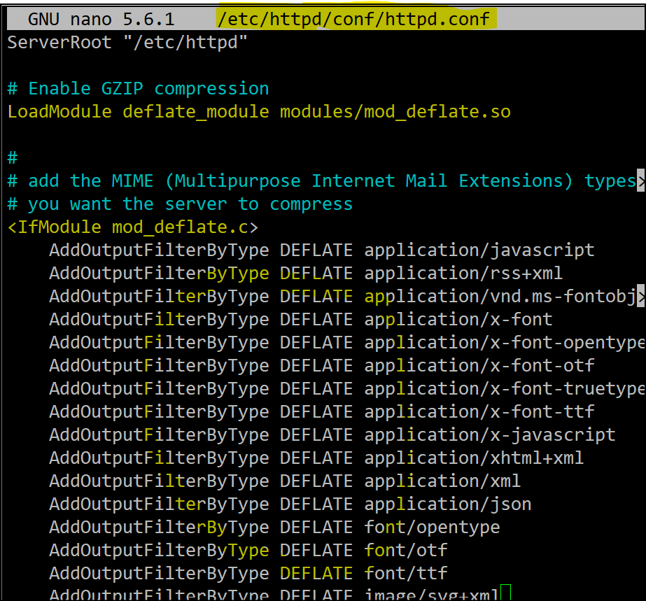

systemctl restart httpd

PS. Gzip compression can be check later after Cacti is completed setup by Press F12 =>Network =>All => Select a php => Header => Response Headers =>content-encoding =>gzip

x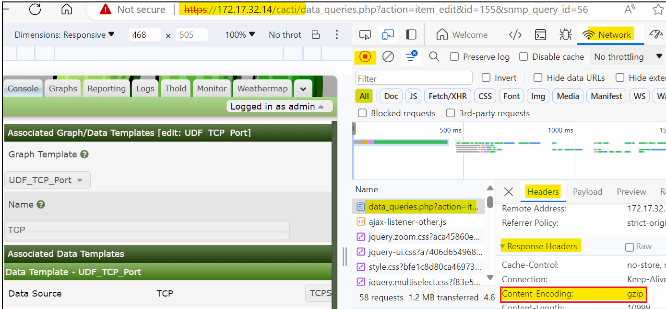

## Disable firewall

systemctl stop firewalld

systemctl disable firewalld

systemctl status firewalld

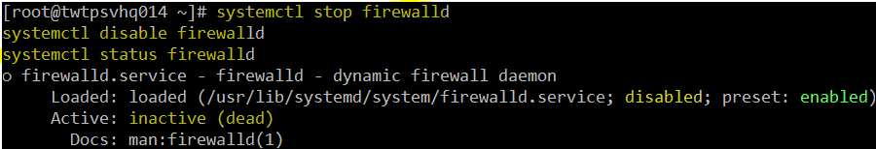

## (Optional) Enable firewall port: http https snmp

firewall-cmd --zone=public --add-service=http --add-service=https --add-service=snmp

firewall-cmd --runtime-to-permanent

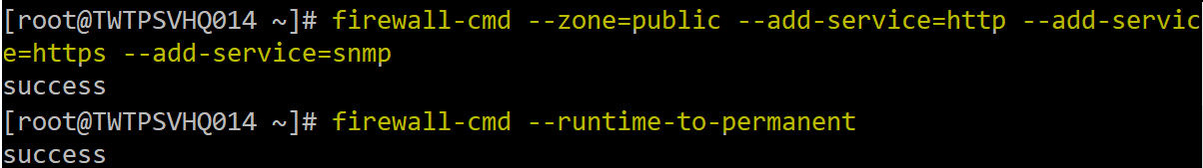

## Install & Configure NTP

#Check NTP daemon is running & source IP

systemctl status chronyd

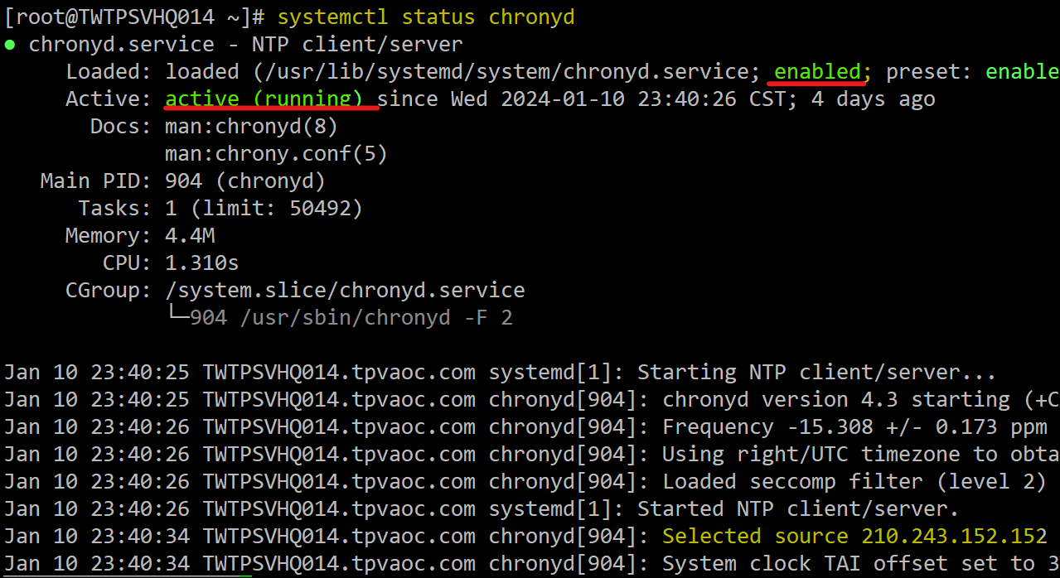

cp /etc/chrony.conf /etc/chrony.conf.bak

nano /etc/chrony.conf

#pool 2.pool.ntp.org iburst

pool 172.16.0.179 iburst

pool 172.16.0.178 iburst

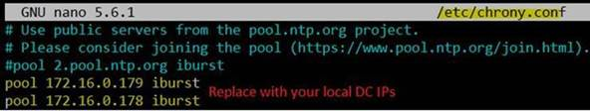

systemctl restart chronyd

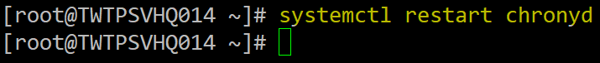

systemctl status chronyd  (verify selected source IP is switch to local DC now)

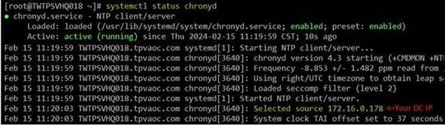

(Optional-Troubleshooting) Reboot now if Selected source IP still not change to your local DC

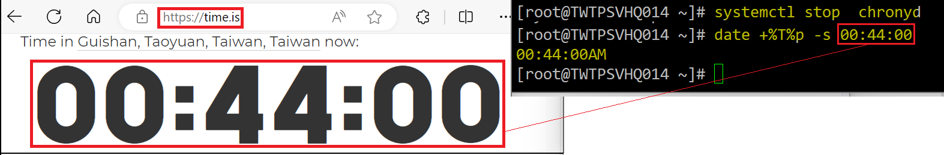

# Cacti Configuration

## Pre-Installation Check

# Default credential is **admin/admin**, change PW to **Tpv@TP2024**

<https://172.17.32.14/cacti>

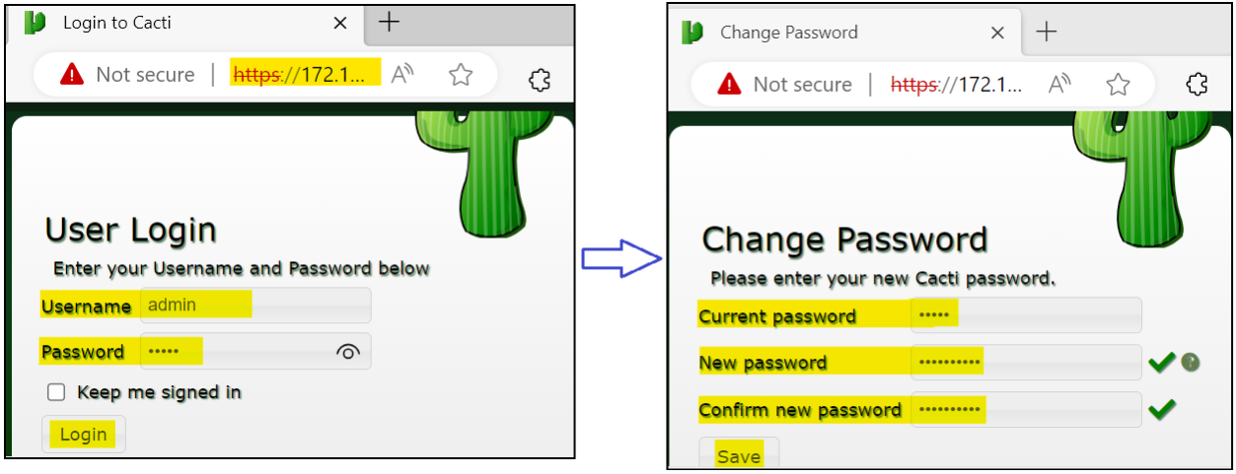

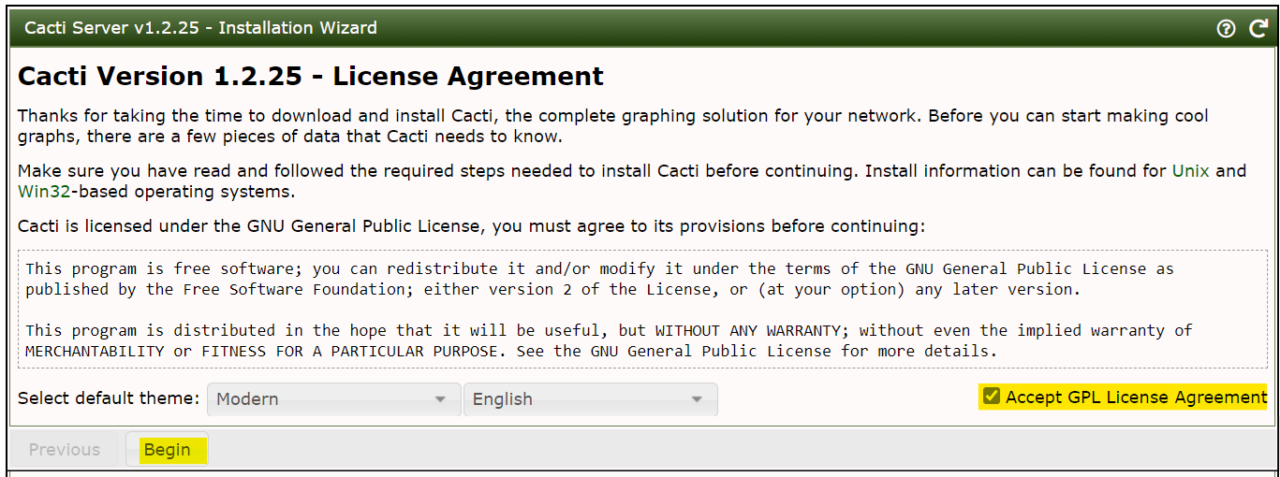   
 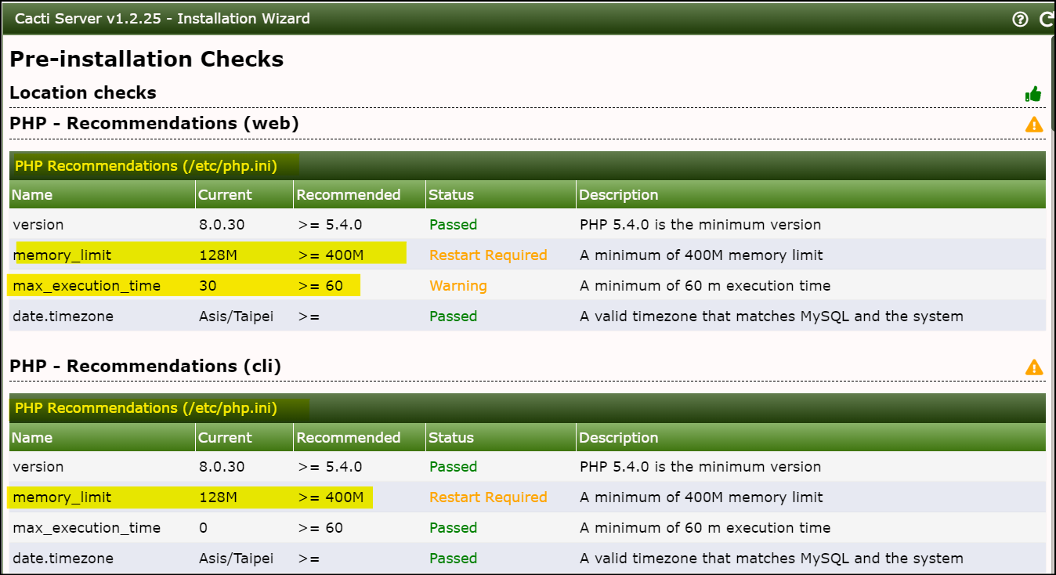  
 🡹Follow up yellow marker to modify /etc/php.ini  
 cp /etc/php.ini /etc/php.ini.bak

nano /etc/php.ini

systemctl restart php-fpm

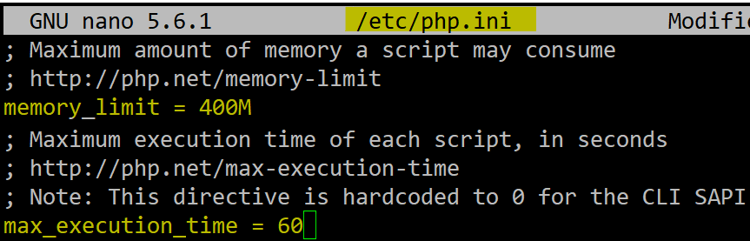



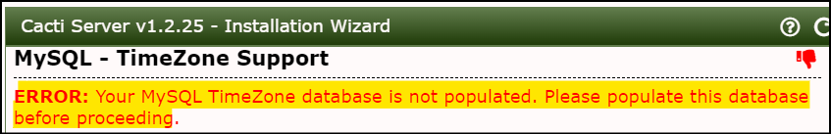

🡹 fix MySql Time zone DB issue

mysql_tzinfo_to_sql /usr/share/zoneinfo | mysql -uroot -pc@Ct1Vser mysql

  
 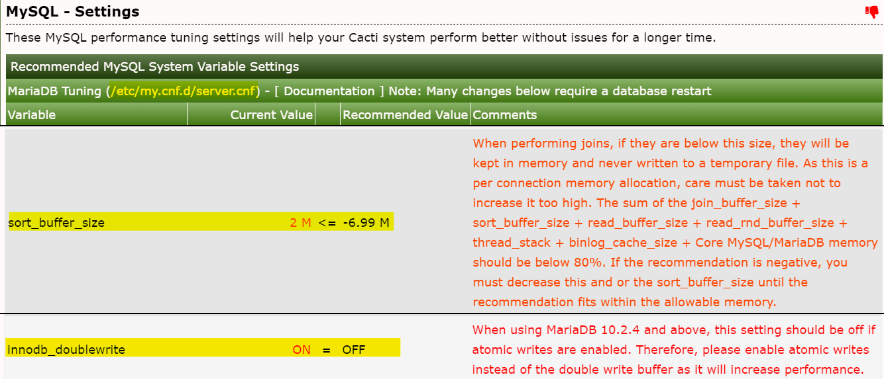

🡹 fix MySql settings issue

cp /etc/my.cnf.d/server.cnf /etc/my.cnf.d/server.cnf.bak

nano /

sort_buffer_size = 10M

join_buffer_size = 15M

innodb_doublewrite = OFF

max_connections = 600

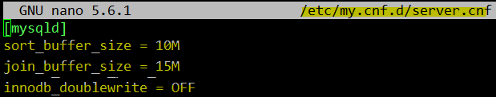

systemctl restart mariadb

Refresh cacti web page to check status are all GREEN thumb UP => Click Next

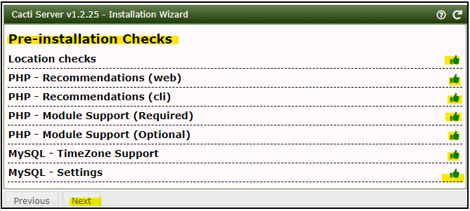  
 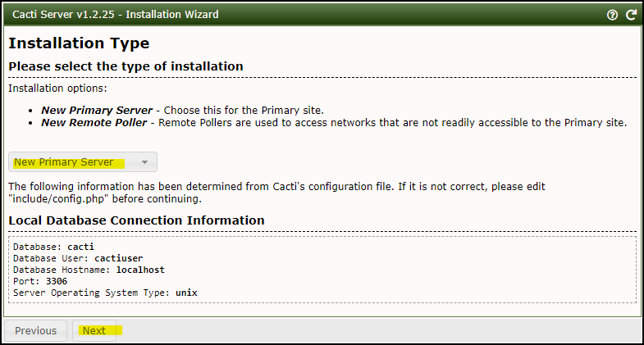

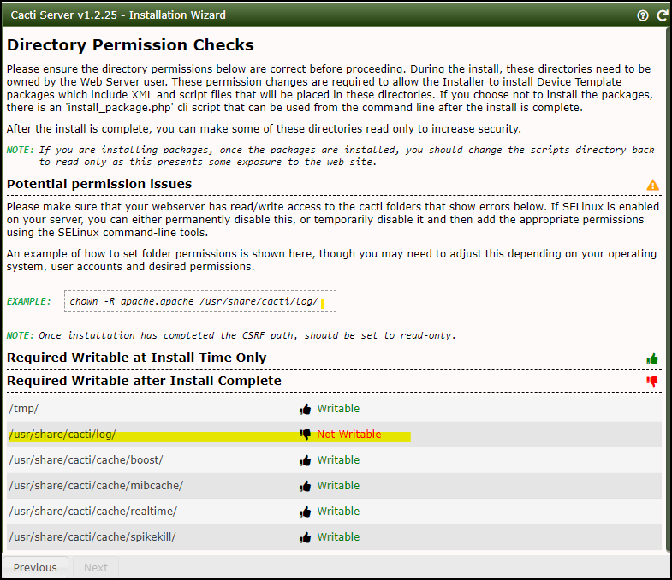

🡹 fix writable permission issue of /usr/share/cacti/log/ by Disable SELinux temporarily

setenforce 0

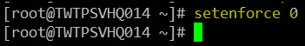

#disable selinux permanently from enforcing to disabled

cp /etc/sysconfig/selinux /etc/sysconfig/selinux.bak

nano /etc/sysconfig/selinux

SELINUX=disabled

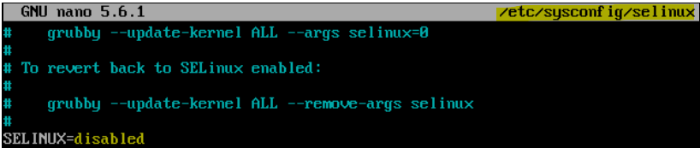

Refresh Cacti web page =>Click Next

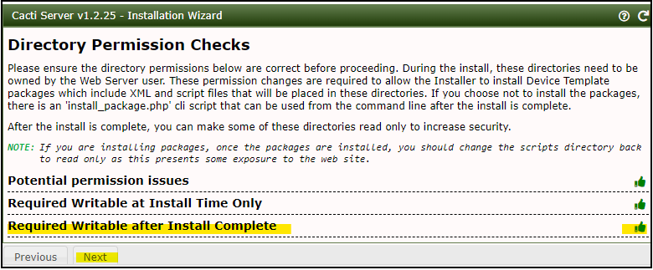

🡻Change spine path later => Select RRDTool 1.8 (default is 1.7.2)

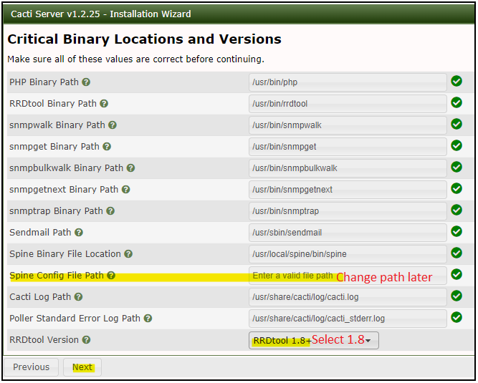

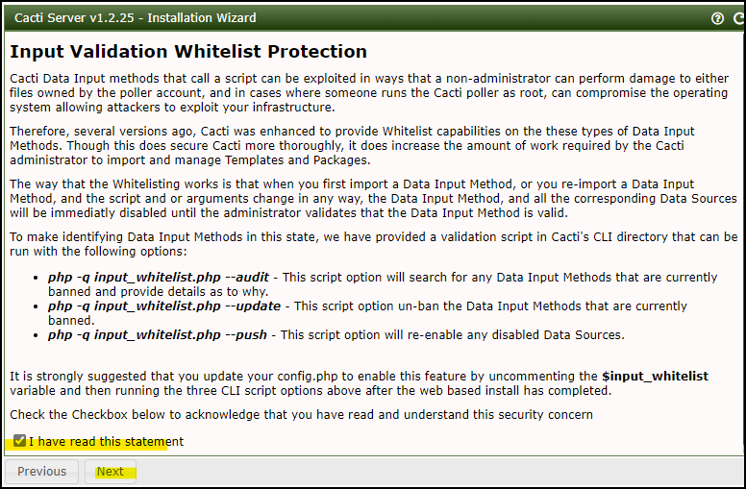

Disable “Scan mode”

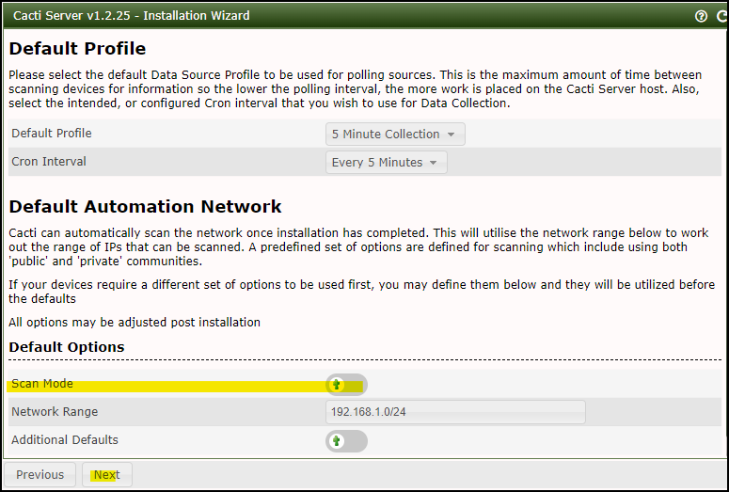

Default all Template are selected. => Next

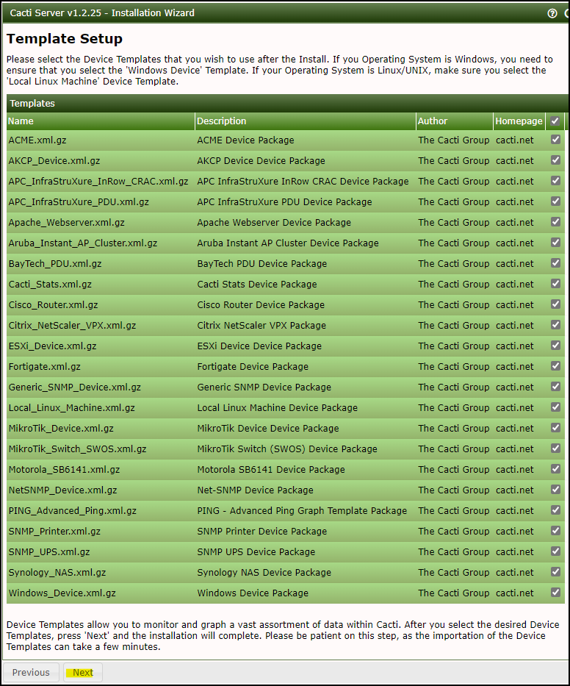

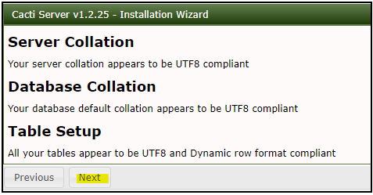

Check “Confirmed Installation” => Install

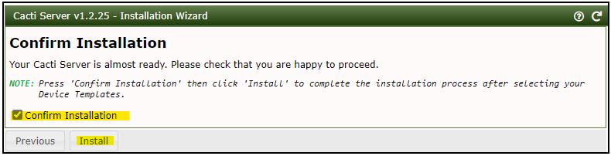

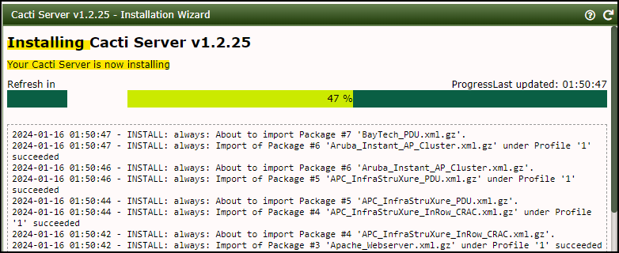

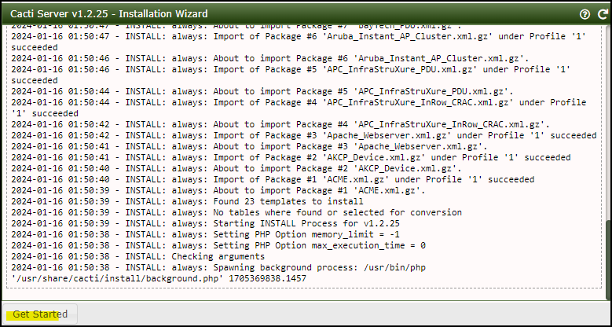

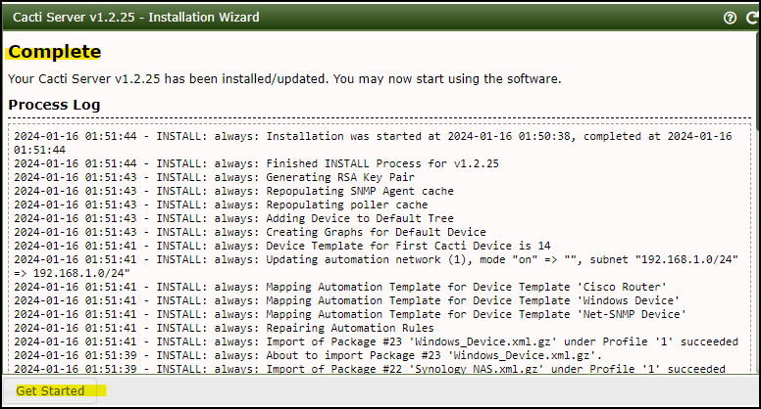

Done.

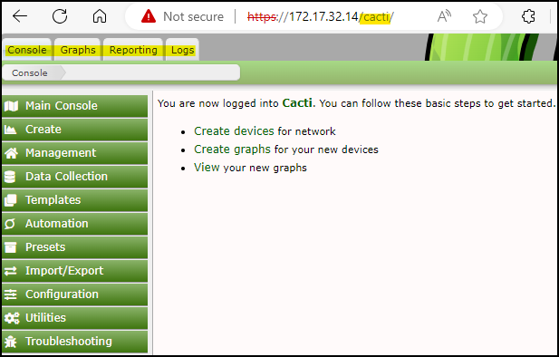

## Configure Cacti

#Define spine execute path to **/usr/local/spine/etc/spine.conf & Enable RRD File Auto Clean**

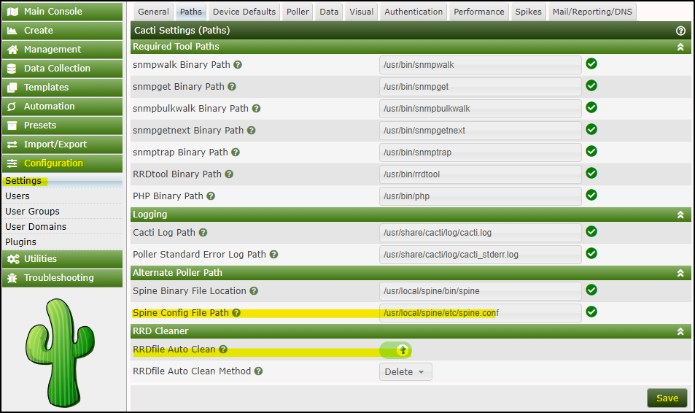

On Device Default.

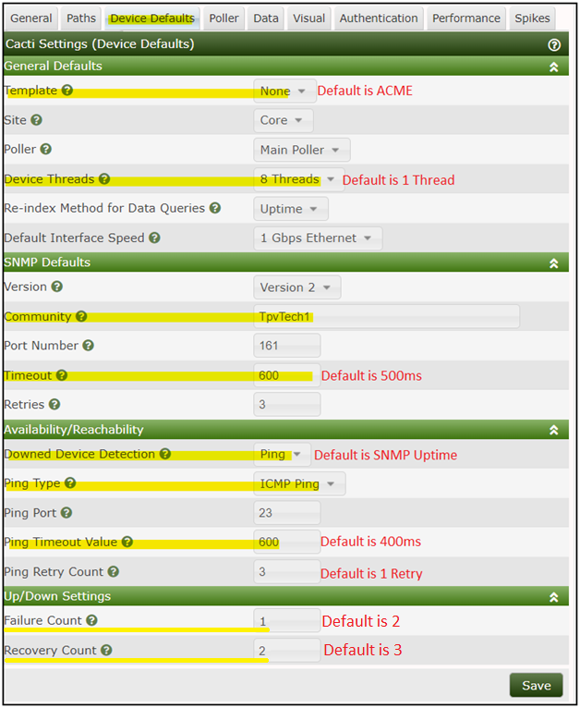

Polling

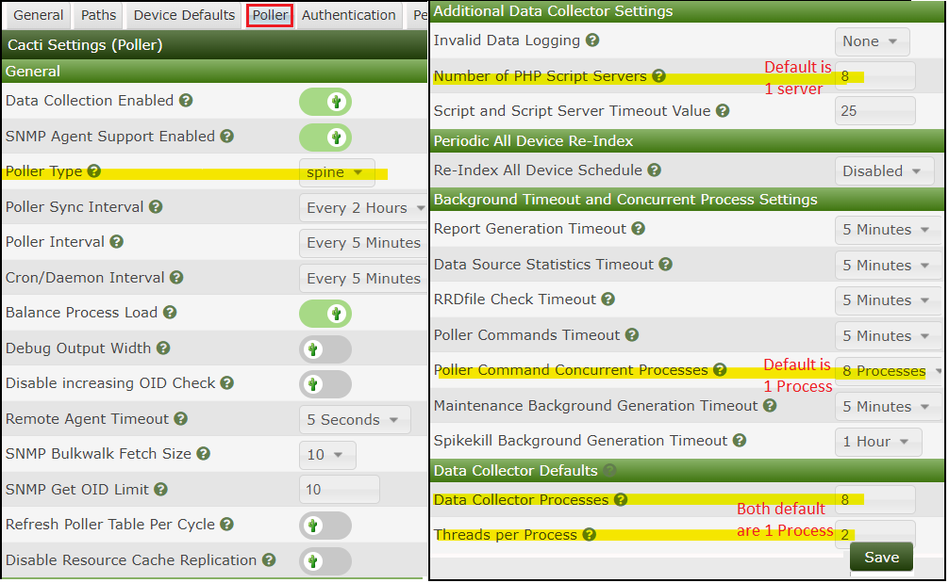

Mail/Reporting/DNS

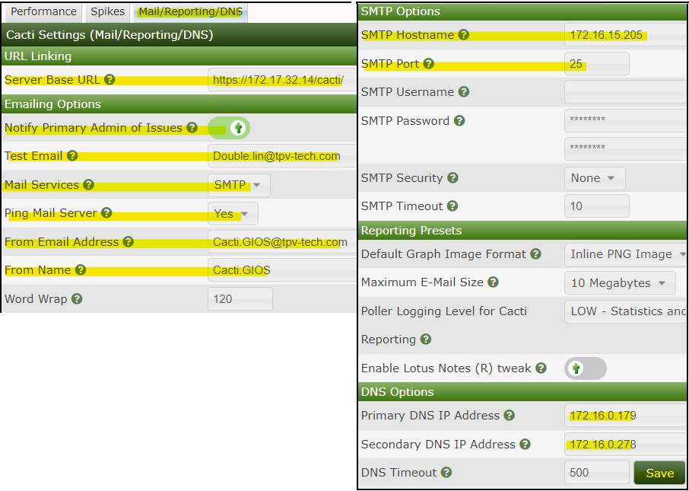

Change Data collectors to your hostname & Time zone

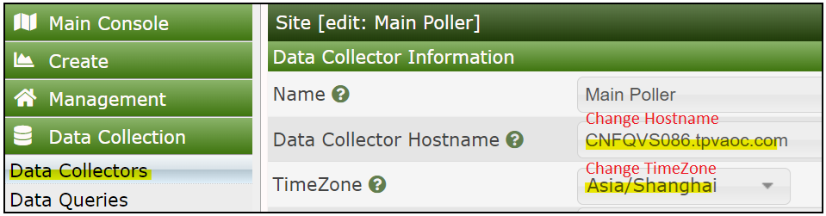

## Install Plug-in

#Install Plug-in, configuration will be in next step.

cd /usr/share/cacti/site/plugins

sudo git clone https://github.com/Cacti/plugin_thold.git

sudo mv plugin_thold thold

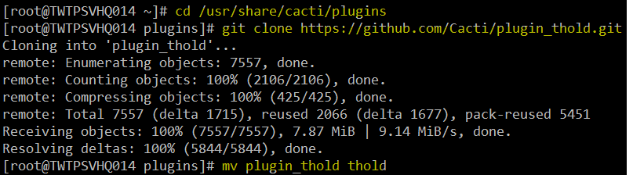

goto configuration=>Plugins=>Install “Thold” =>Enable “Thold”

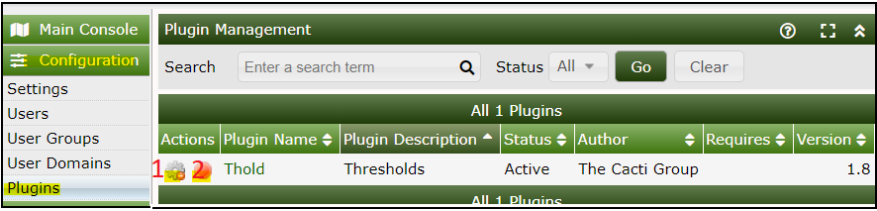

#Repeat above to install other plug-ins

git clone <https://github.com/Cacti/plugin_maint>

mv plugin_maint maint

git clone <https://github.com/Cacti/plugin_monitor>

mv plugin_monitor monitor

git clone <https://github.com/Cacti/plugin_weathermap>

mv plugin_weathermap weathermap

git clone <https://github.com/Cacti/plugin_syslog>

mv plugin_syslog syslog

git clone <https://github.com/Cacti/plugin_wmi>

mv plugin_wmi wmi

git clone <https://github.com/Cacti/plugin_webseer>

mv plugin_webseer websee

git clone <https://github.com/Cacti/plugin_flowview>

mv plugin_flowview flowview

goto configuration=>Plugins=>Install “Thold” =>Enable plug-ins

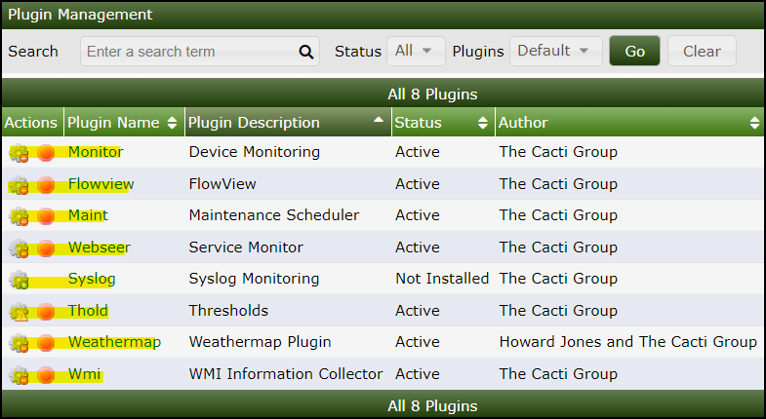

Disable Cacti alert mail when add a New Device into monitor

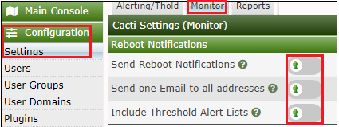

## Enable thold as a service

cp /usr/share/cacti/plugins/thold/service/systemd/thold_daemon.service /etc/systemd/system

nano /etc/systemd/system/ thold_daemon.service

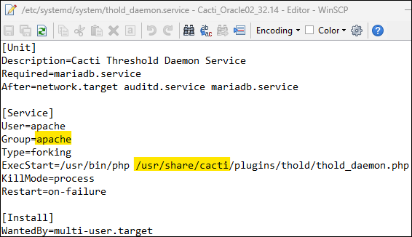

chmod +x /usr/share/cacti/plugins/thold/thold_daemon.php

systemctl daemon-reload



systemctl start thold_daemon

systemctl status thold_daemon

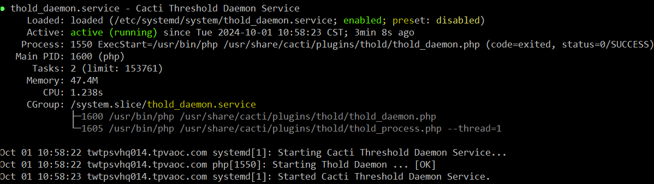

## Enable 1 minute data collection and keep 1 month & 1Year

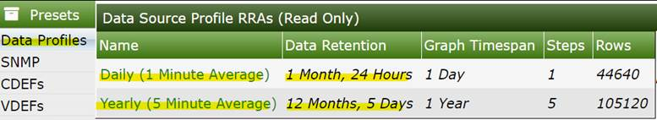

1. 日圖: 用於故障排排& 效能優化. 1min採樣, 保留1個月.
2. 年圖: 用於歷史數據回顧. 5mins採樣, 保留1年. 使用場景如：D:碟過去一年使用率的增長趨勢, 過去一年這條Internet線路的頻寬使用狀況. 以做為設備增購參考.
3. 提高準確度: 會較現況年圖增加288倍 (1440min/5min), 因為現況年圖是24小時(1440 mins)取樣,新版5分鐘.

Preset=>Data Profile =>Click ‘+” =>   
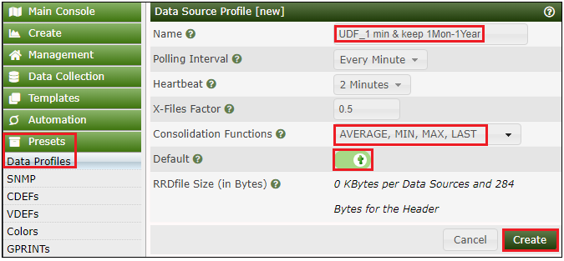  
Click ‘+’  
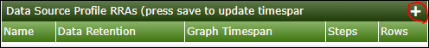

Create “Daily (1 Minute Average) =>44640 => 1 Day => Create  
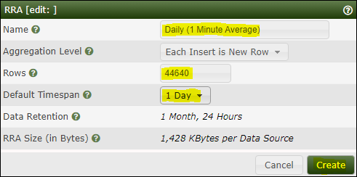

Click ‘+’  
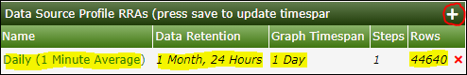

Create “Yearly (5 Minute Average)” =>5 minutes =>105120 rows=>1 year =>Create

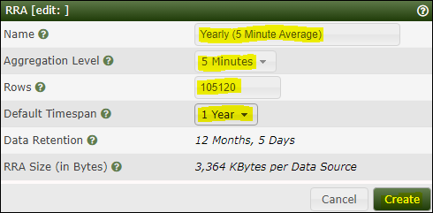

Click Save =>Done

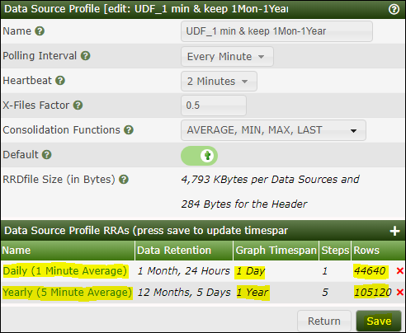

Replace all Template ‘data sources’ with new profile

Template => Data Source => Data Template “750” => select ALL data sources => “Change Profile” =>Go

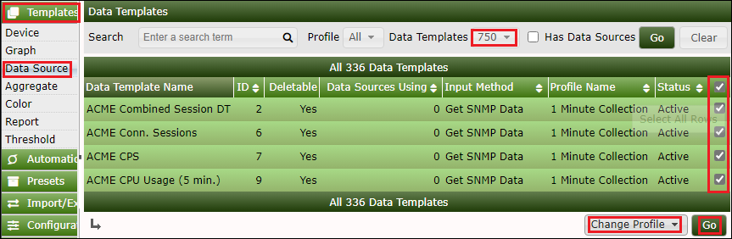

Select “UDF_1 min & Keep 1mon-1Year”=>Continue  
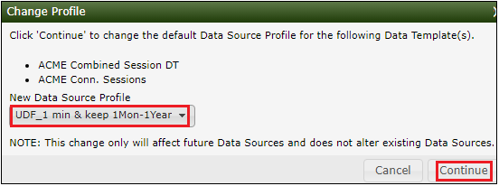  
Done.  
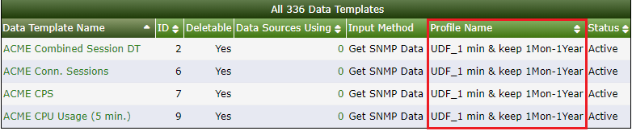

## Import Monitor Template – Win Service & TCP Port & Linux process

cacti_graph_template_udf_tcp_port.xml

cacti_graph_template_udf_winservices.xml

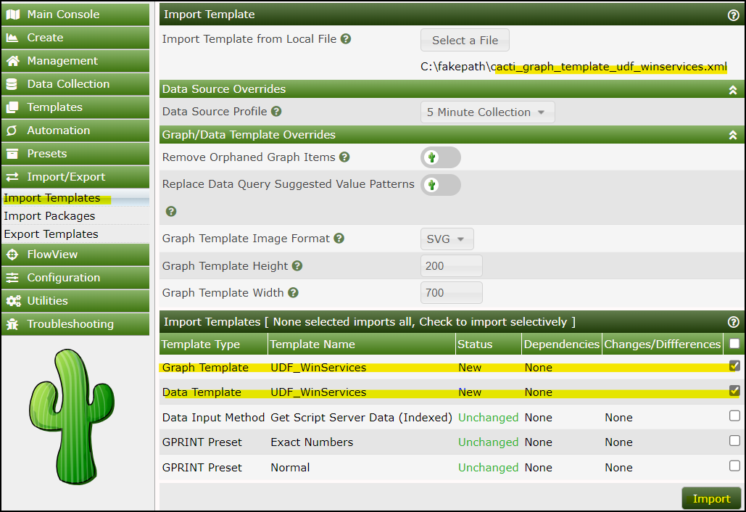

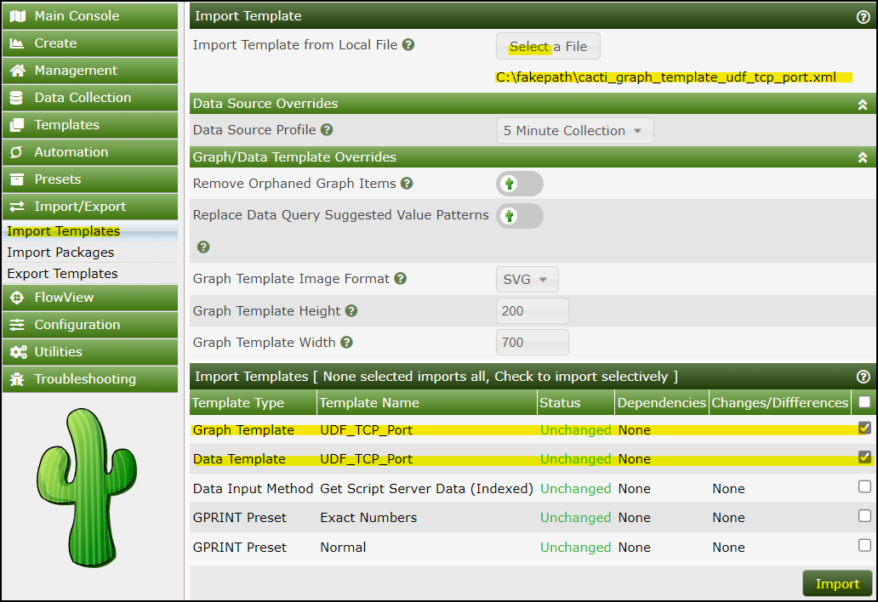

/usr/share/cacti/resource/script_server/tcp.xml

/usr/share/cacti/resource/script_server/win_services.xml

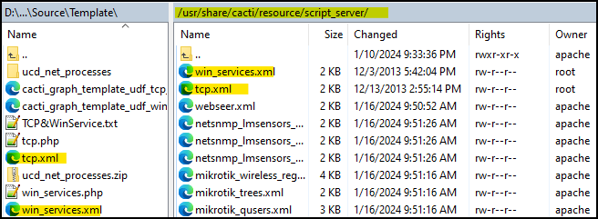

/usr/share/cacti/scripts/tcp.php

/usr/share/cacti/scripts/win_services.php

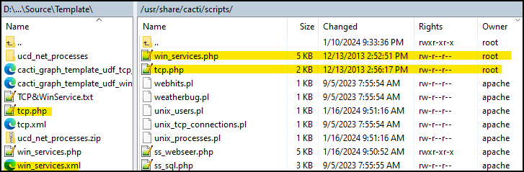

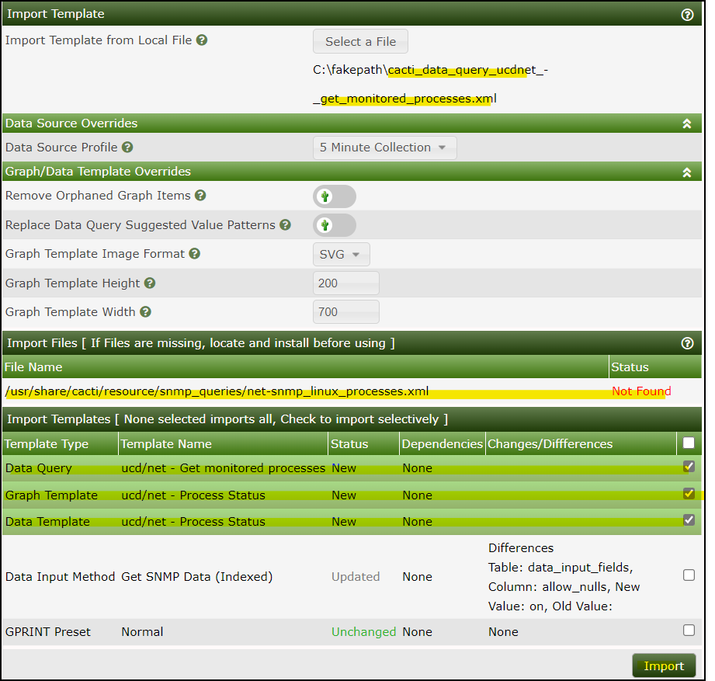

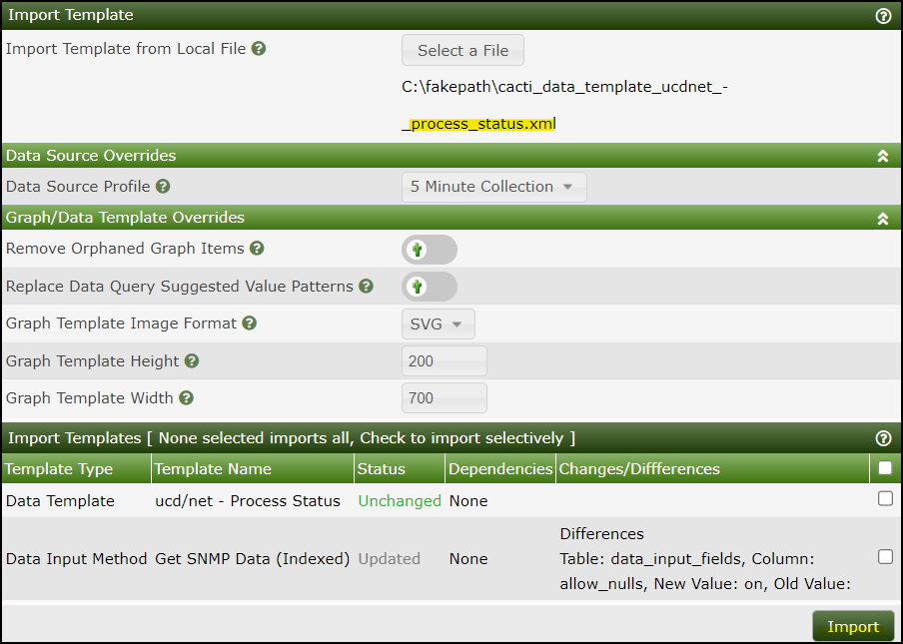

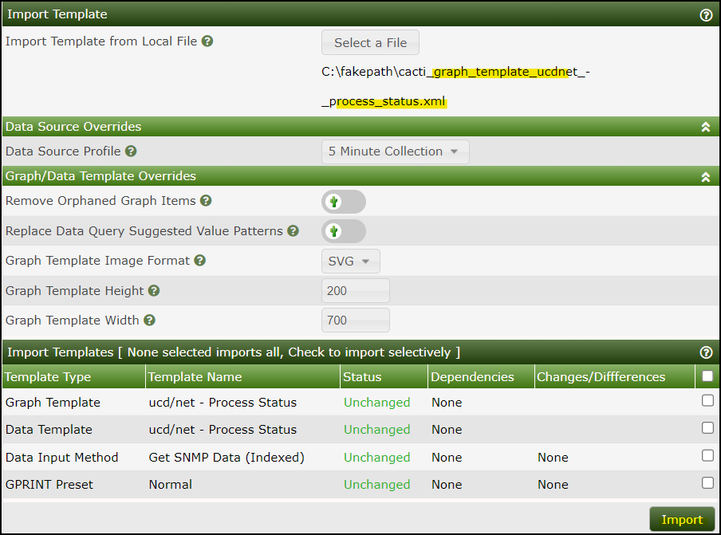

Copy **net-snmp_linux_processes.xml** to /usr/share/cacti/resource/snmp_queries directory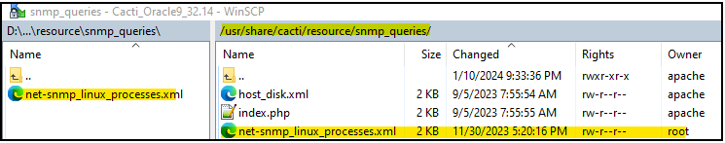

# Change owner from root to apache:apache

chown apache:apache /usr/share/cacti/resource/script_server/tcp.xml

chown apache:apache /usr/share/cacti/resource/script_server/win_services.xml

chown apache:apache /usr/share/cacti/scripts/tcp.php

chown apache:apache /usr/share/cacti/scripts/win_services.php

chown apache:apache /usr/share/cacti/resource/snmp_queries/net-snmp_linux_processes.xml

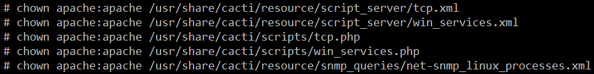

##Append linux process that required to be monitor

nano /etc/snmp/snmpd.conf

#### Process monitor

proc apache2 10 1

proc httpd 10 1

proc mariabd 10 1

proc nano 10 1

proc snmpd 10 1

proc sshd 10 1

proc vmtoolsd 10 1

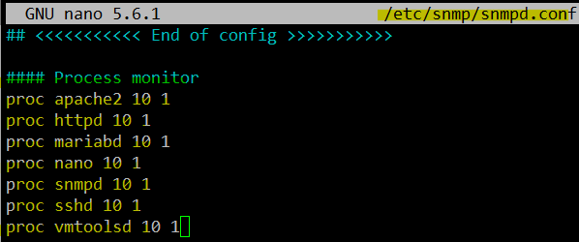

## Improve data collection performance

Configuration => Setting =>Poller =>Data Collector Default => increase 2 values to 16 & 20 as below.

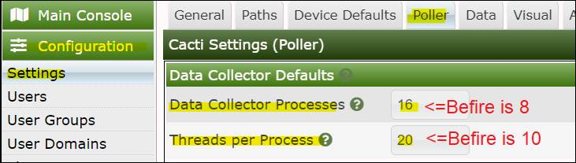  
Benchmark:

1. Data collected duration improved from 22seconds to 13 seconds based on GIOS 530 monitored items. Result is graphs are stable without any broken.
2. Methodology is increase poller threshold from default 80 to 320 (4 times).

## (Optional) Install Chinese language pack

sudo yum install langpacks-zh_CN

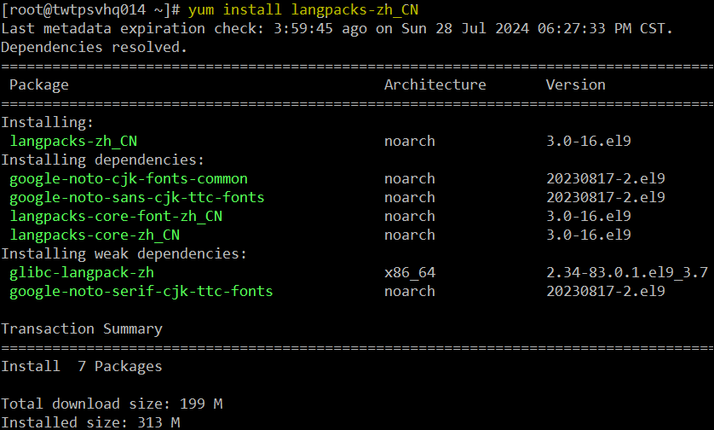

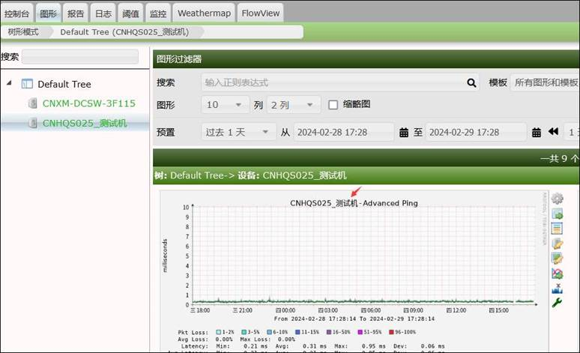

# Add Cacti into Monitor

## Configure SNMP

cp /etc/snmp/snmpd.conf /etc/snmp/snmpd.conf.bak

nano /etc/snmp/snmpd.conf

############################################

# SNMP configuration #

############################################

# Agent address

agentaddress udp:161

agentaddress udp6:161

## Access control

# sec.name source community

com2sec AllowAll **127.0.0.1 TpvTech1**

#group <group_name> <security_mode> <security_name>

group AllGroup v2c AllowAll

# Define 'AllView', which includes everything under .1

# view.name incl/excl subtree.mask(Optional)

view AllView included .1

# group.name context model level prefix read write notify

access AllGroup "" any noauth exact AllView none none

## System contact information

#syslocation <location set>

#syscontact <contact_info>

syslocation Cacti.GIOS@Taipei

syscontact Double.lin@tpv-tech.com

## <<<<<<<<<<< End of config >>>>>>>>>>>

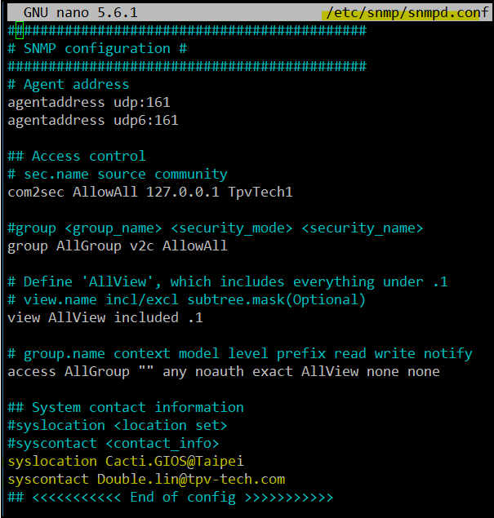

systemctl enable snmpd

systemctl restart snmpd

systemctl status snmpd

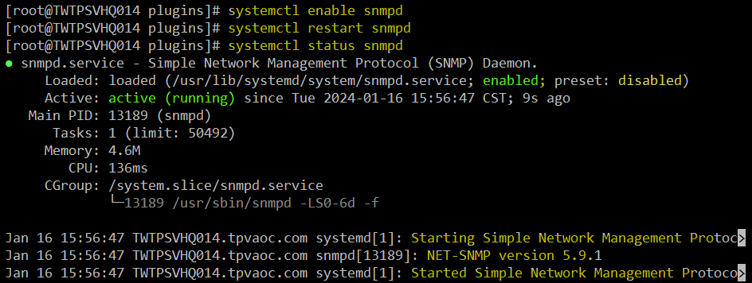

## Configure Cacti Service to monitor

##Append Linux process that required to be monitor

nano /etc/snmp/snmpd.conf

#### Process monitor

proc apache2 10 1

proc httpd 10 1

proc mariabd 10 1

proc nano 10 1

proc snmpd 10 1

proc sshd 10 1

proc vmtoolsd 10 1



## Add Cacti device

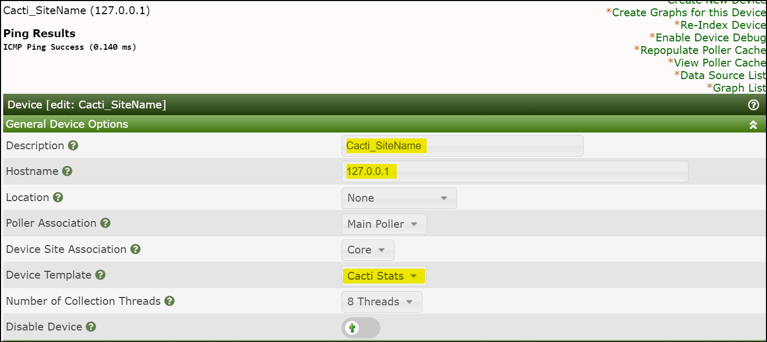

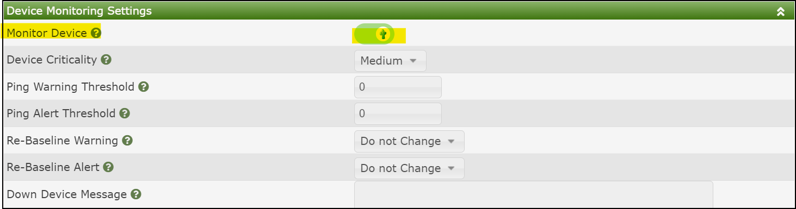

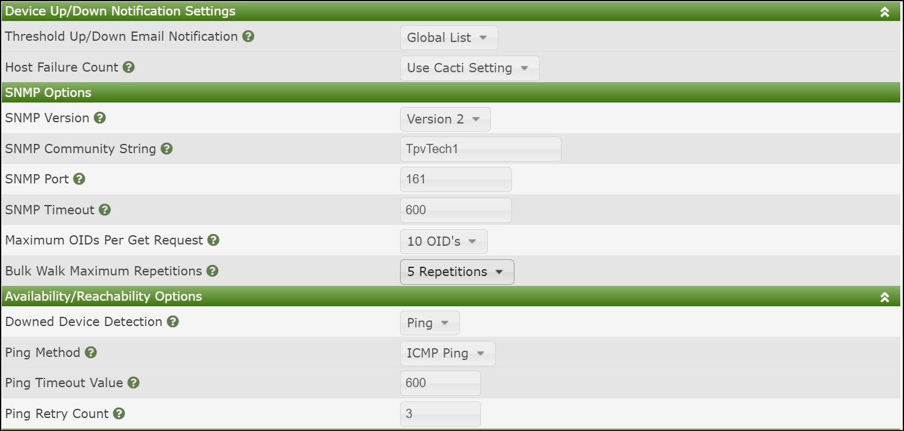

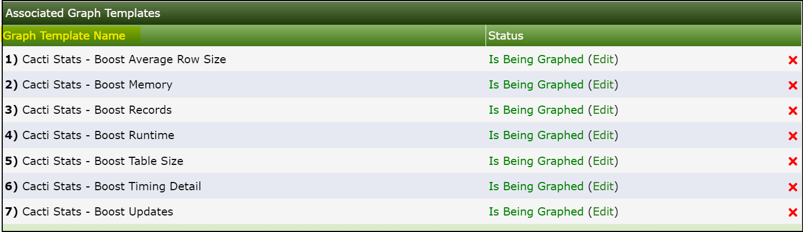

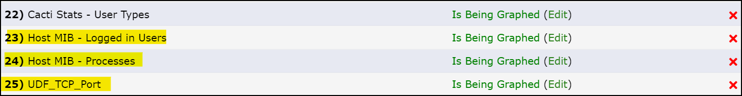

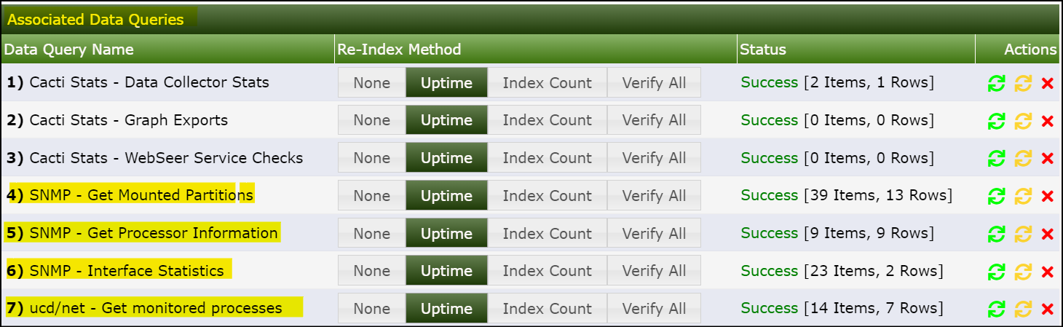

# Enable syslogs plugin

Goal: Function will receive Cacti mail notification in 1~2 minutes, since Server generate error logs

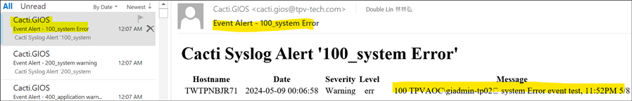

#create a dedicated DB for syslog

nano /etc/my.cnf.d/server.cnf

sql_mode=NO_ENGINE_SUBSTITUTION,NO_AUTO_CREATE_USER

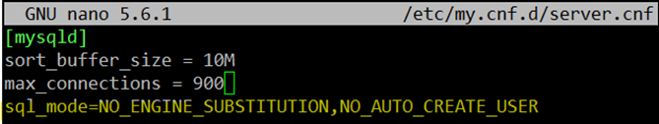

mysql -u root -p

show global variables like 'sql_mode';

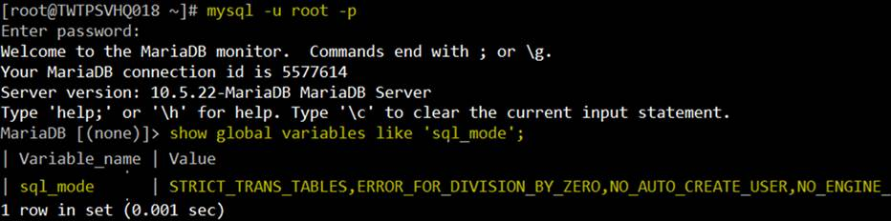

create database syslog;

GRANT ALL ON syslog.* TO 'cactiuser'@'localhost';

flush privileges;  
exit;

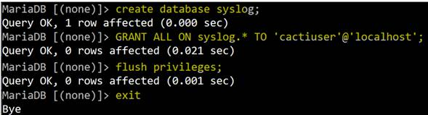

#Configure rsyslog by

nano /etc/rsyslog.d/cacti.conf

##cacti.conf is a new file, copy and paste below lines

$ModLoad imudp

$UDPServerRun 514

$ModLoad ommysql

$template cacti_syslog,"INSERT INTO syslog_incoming(facility_id, priority_id, program, logtime>

  values (%syslogfacility%, %syslogpriority%, '%programname%', '%timegenerated:::date-mysql%',>

*.* >localhost,my_database,my_user,my_password;cacti_syslog  
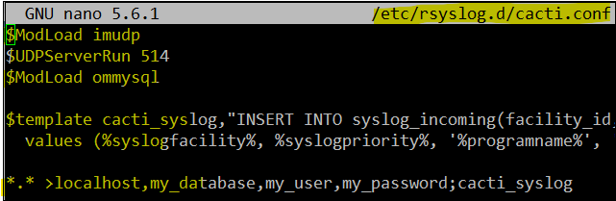

#Install rsyslog-mysql package

yum -y install rsyslog-mysql

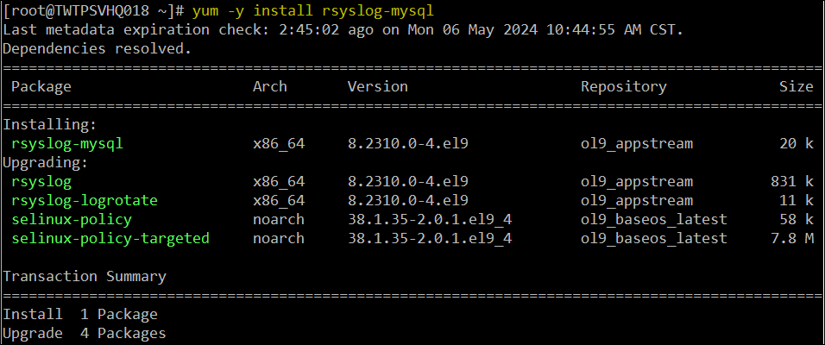

systemctl restart rsyslog



#configure syslog & DB connection

cd /usr/share/cacti/plugins/syslog

cp config.php.dist config.php

nano config.php

            $use_cacti_db = false;  
            $syslogdb_password = 'c@CtiVser';

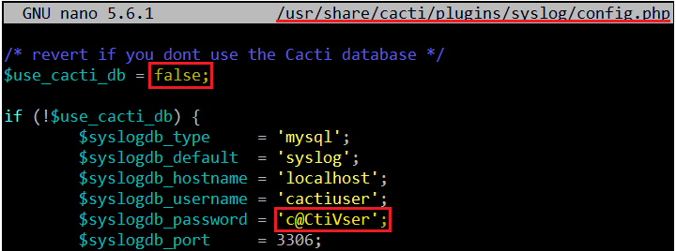

#Enable syslog as a service

cp /etc/rsyslog.d/cacti.conf.dist /etc/rsyslog.d/cacti.conf

cp /usr/share/cacti/plugins/syslog/config.php.dist /usr/share/cacti/plugins/syslog/config.php

cd /usr/share/cacti/plugins/syslog

cp config.php.dist /etc/rsyslog.d/cacti.conf

nano /etc/rsyslog.d/cacti.conf

rm nano /etc/rsyslog.d/cacti.conf

nano /etc/rsyslog.d/cacti.conf

yum -y install rsyslog-mysql

systemctl restart rsyslog

cp config.php.dist config.php

nano config.php

#Enable plug-in

Configuration =>Plugins =>Click red circle “Gear” to install

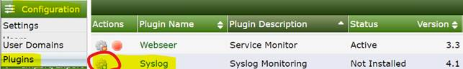

1 day for retention => Install

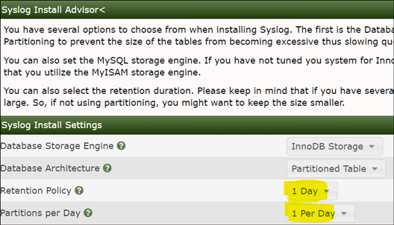

Click green point to activate => change to red & status in Active.

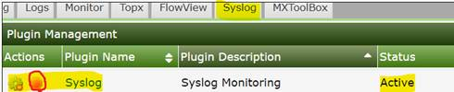  
#Enable Win Server to export logs by follow attachment.

#On win server, generate testing event logs

eventcreate /t error /id 100 /l system /d “system Error event test, 11:12PM 5/8“

eventcreate /t warning /id 200 /l system /d “system warning event test, 11:12PM 5/8“

eventcreate /t error /id 300 /l application /d "application Error event test, 11:12PM 5/8“

eventcreate /t warning /id 400 /l application /d "application warning event test, 11:12PM 5/8"

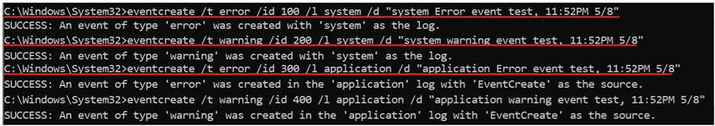  
#Check result: Syslog => System Logs

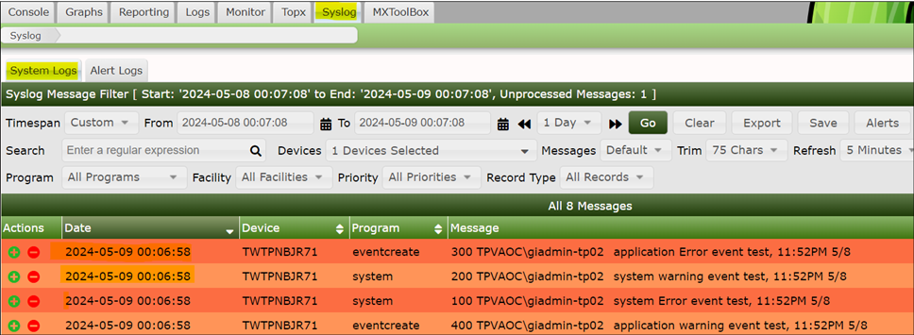

#Create alert

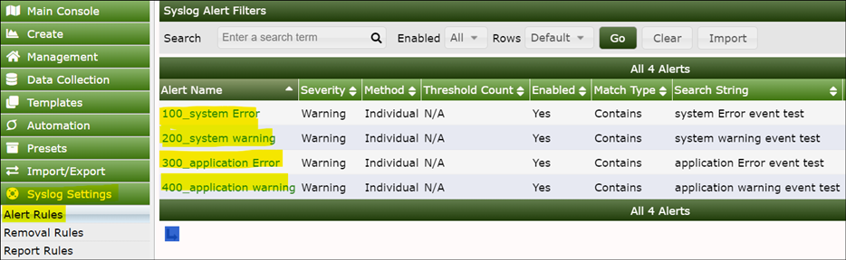

#Check alerts mail

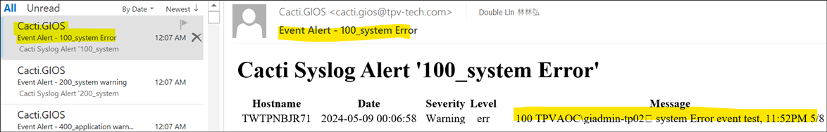

#On Cacti, use tcp dump to check if received event logs from Win Svr.

tcpdump -i ens192 host 172.17.36.19 and port 514

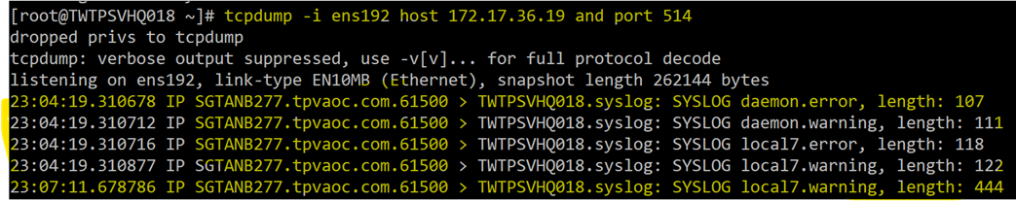

# Enable flowview plugin

Goal: Function will receive Cacti mail notification in 1~2 minutes, since Server generate error logs

## Create a dedicated disk partition 200GB for flowview DB

#on vCenter, add a new 200GB partition to Cacti VM

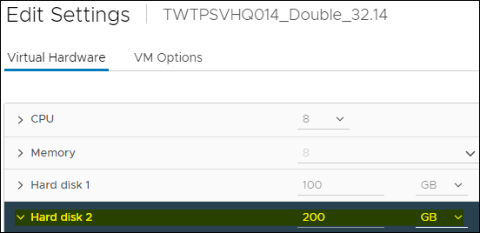

#list current disk partition

lsblk

#sdb is new disk name & size is 200G

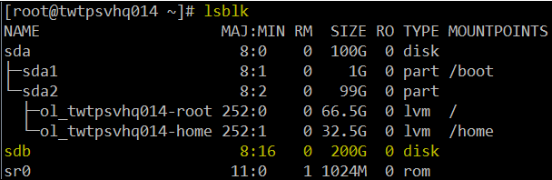

#Create new partition with name “flowview” on new disk-sdb

fdisk /dev/sdb

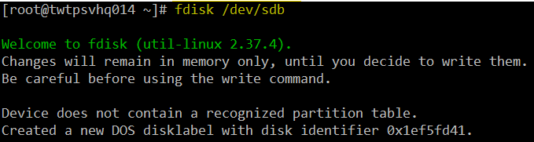

Type n => create a new partition

Type p => create a primary partition

Type 1 => 1st partition number

Type Enter twice => to use default value of beginning and end sector number

Type w => save settings.

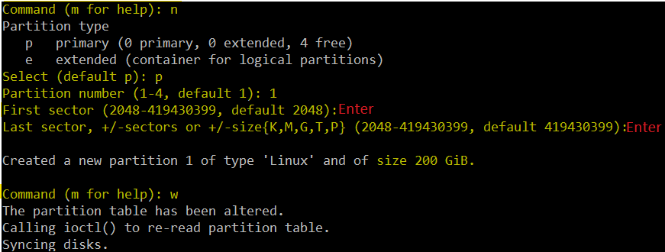

mkfs.xfs /dev/sd**b1**

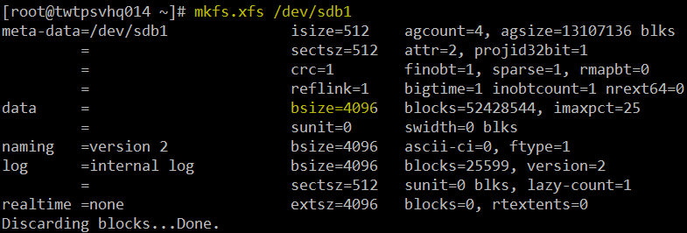

#create a mount point “flowview” for sdb1

mkdir /**flowview**

mount /dev/sd**b1** /flowview



#verify new partition created and mounted

lsblk -f

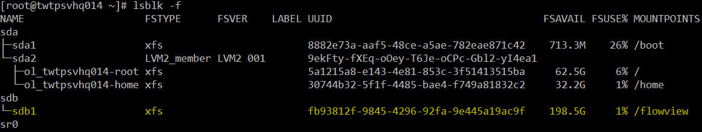

copy flowview’s UUID: fb93812f-9845-4296-92fa-9e445a19ac9f

#Auto mount flowview partition during server booting, adding new 1 line as below

nano /etc/fstab

UUID=fb93812f-9845-4296-92fa-9e445a19ac9f /flowview xfs defaults 0 0

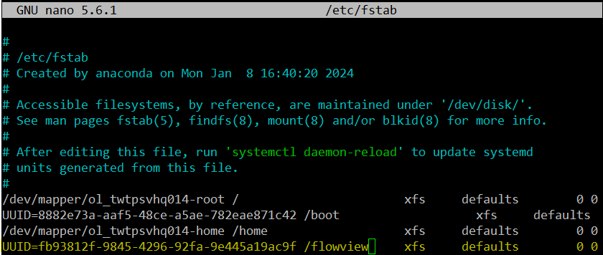

systemctl daemon-reload



reboot now

` 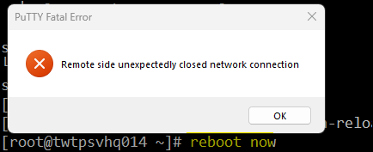

#verify flowview mounted successful.

lsblk -f

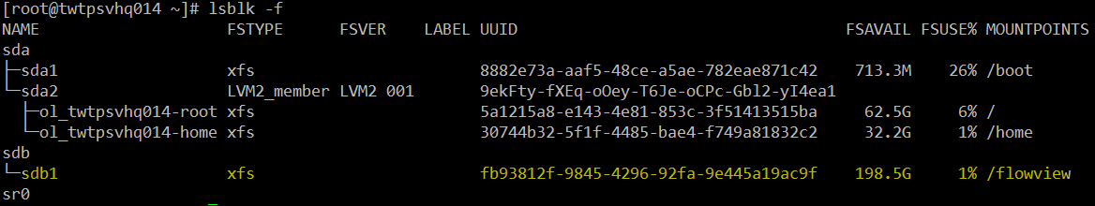

## Create a dedicated DB for flowview

mysql -uroot

create database flowview;

GRANT ALL ON flowview.* TO 'cactiuser'@'localhost';

flush privileges;

exit;

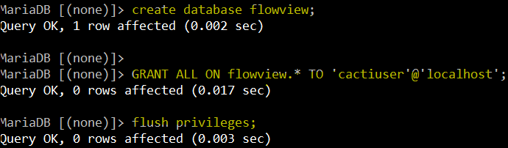

# verify DB is NO table

mysqlshow -uroot flowview

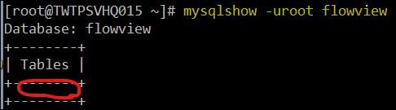

#verify flowview db folder created

ls -lh /var/lib/mysql/flowview/

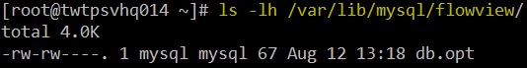

#move flowview folders to new partition-flowview

systemctl stop httpd

systemctl stop mariadb

mv /var/lib/mysql/flowview /flowview/

ln -s /flowview/flowview /var/lib/mysql/flowview

systemctl start mariadb

systemctl start httpd

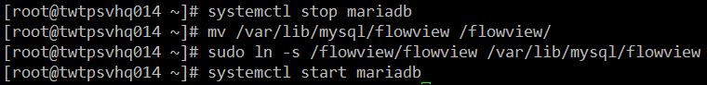

#verify symbol link created

ls -lh /flowview/

ls -lh /var/lib/mysql/flowview/

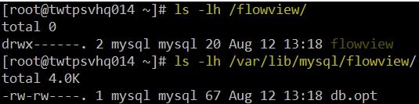

## Flowview install & configure

WinSCP Flowview develop version v4.4_07282024 & rename

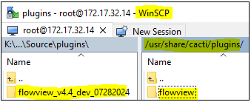

cd /usr/share/cacti/plugins/flowview/

cp config.php.dist config.php

nano config.php

change from truth to **false**

use **same credential with cacti (change PW)**

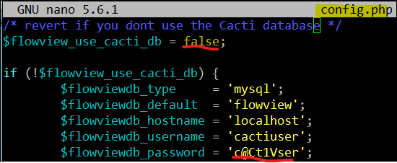

cp ./service/flow-capture.service /etc/systemd/system

#Modify flowview service 3 paths to **/usr/share/**…..

nano /etc/systemd/system/flow-capture.service

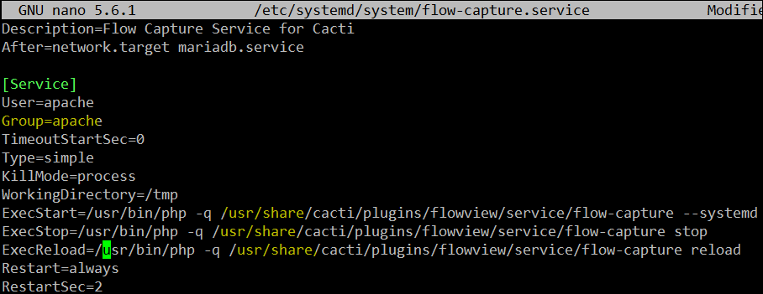

#On Cacti console, Install flowview plugin

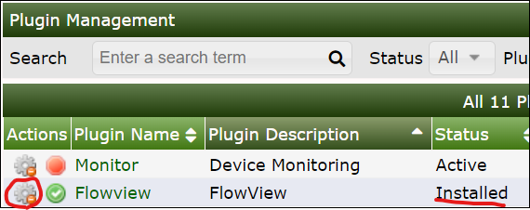

#//verify tables created

mysqlshow -uroot flowview

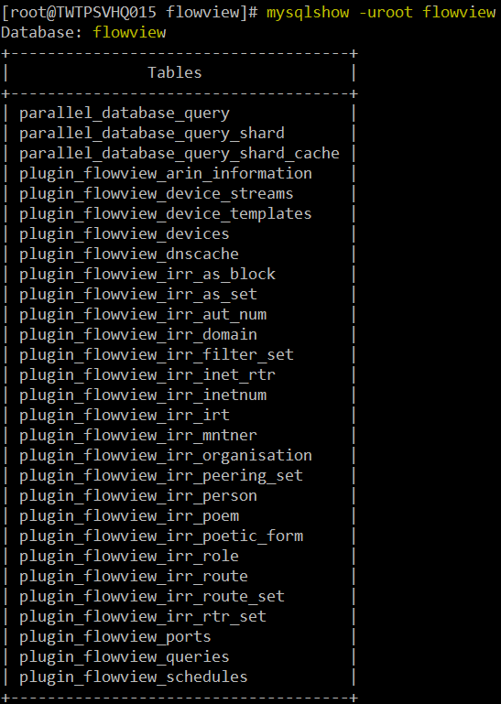

systemctl start flow-capture

systemctl enable flow-capture

systemctl status flow-capture  
 

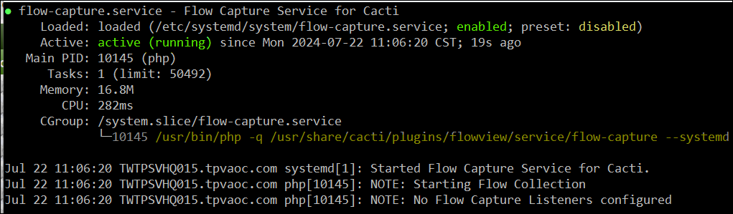

Reduce data retention to **1 week** (default is 1 month) & **16 Threads** (default is 4) on flowview Web Console, and below yellow marked.

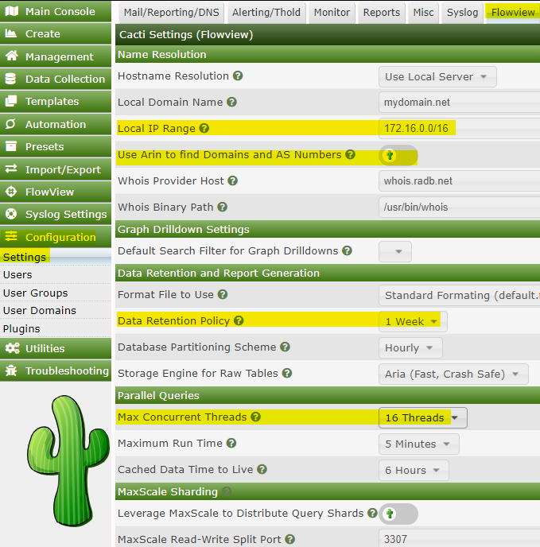

Active flowview plugin

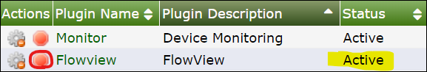

#Check logs & Solve error logs

Error: CMDPHP ERROR: A DB Row Failed!, Error: Table 'flowview.reports_que

#CREATE TABLE `reports_queued`

mysql -uroot flowview -e "

CREATE TABLE IF NOT EXISTS \`reports_queued\` (

\`id\` int(10) unsigned NOT NULL AUTO_INCREMENT,

\`name\` varchar(64) NOT NULL DEFAULT '',

\`source\` varchar(20) NOT NULL DEFAULT '',

\`source_id\` int(10) unsigned NOT NULL DEFAULT 0,

\`status\` varchar(10) NOT NULL DEFAULT 'pending',

\`scheduled_time\` timestamp NOT NULL DEFAULT '0000-00-00',

\`start_time\` timestamp NOT NULL DEFAULT '0000-00-00',

\`run_command\` varchar(512) NOT NULL DEFAULT '',

\`run_timeout\` int(10) NOT NULL DEFAULT '60',

\`notification\` blob NOT NULL,

\`request_type\` int(10) unsigned NOT NULL DEFAULT 0,

\`requested_by\` varchar(20) NOT NULL DEFAULT '',

\`requested_id\` int(11) NOT NULL DEFAULT -1,

PRIMARY KEY (\`id\`),

KEY \`source\` (\`source\`),

KEY \`source_id\` (\`source_id\`)

) ENGINE=InnoDB

ROW_FORMAT=DYNAMIC

COMMENT='Holds Scheduled Reports';

"

 CMDPHP ERROR: A DB Row Failed!, Error: Table 'flowview.reports_log' doesn't exist

mysql -uroot flowview -e "

CREATE TABLE IF NOT EXISTS \`reports_log\` (

\`id\` int(10) unsigned NOT NULL AUTO_INCREMENT,

\`name\` varchar(64) NOT NULL DEFAULT '',

\`source\` varchar(20) NOT NULL DEFAULT '',

\`source_id\` int(10) unsigned NOT NULL DEFAULT 0,

\`report_output_type\` varchar(5) NOT NULL DEFAULT '',

\`report_raw_data\` longblob,

\`report_raw_output\` longblob,

\`report_txt_output\` longblob,

\`report_html_output\` longblob,

\`notification\` blob NOT NULL,

\`send_type\` int(10) unsigned NOT NULL DEFAULT 0,

\`send_time\` timestamp NOT NULL DEFAULT current_timestamp(),

\`run_time\` double NOT NULL DEFAULT 0,

\`sent_by\` varchar(20) NOT NULL DEFAULT '',

\`sent_id\` int(11) NOT NULL DEFAULT -1,

PRIMARY KEY (\`id\`),

KEY \`source\` (\`source\`),

KEY \`source_id\` (\`source_id\`)

) ENGINE=InnoDB

COMMENT='Holds All Cacti Report Output';

"

DBCALL ERROR: SQL Save on table 'reports_queued': Column 'request_type' does not exist, unable to save!

#Check columes’s name of this table.

mysql -uroot -e "SHOW COLUMNS FROM flowview.reports_queued;"

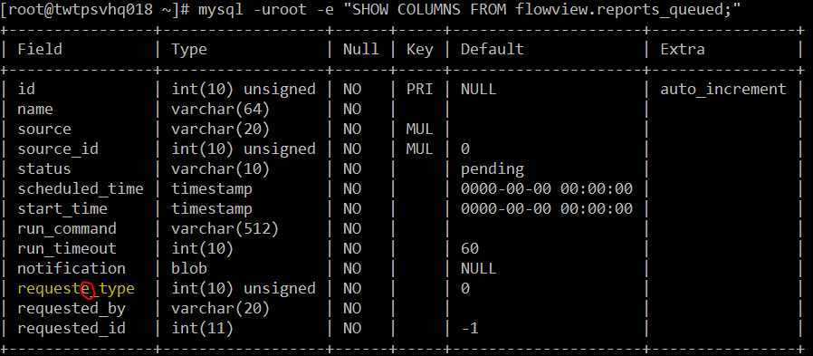

Result is filename is incorrect, “e” is typo.

#On table “reports_queued”, replace column’s name from "requeste_type" to "request_type"

mysql -uroot flowview -e "ALTER TABLE flowview.reports_queued CHANGE COLUMN requeste_type request_type int(10) unsigned NOT NULL DEFAULT 0;"

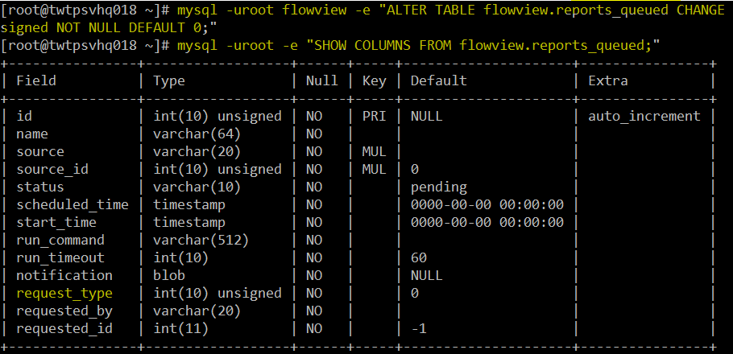

## Configure flowview generator simulator

Download and Configure NetFlow Generator to create test flow source traffic on UDP port 9099, version 9

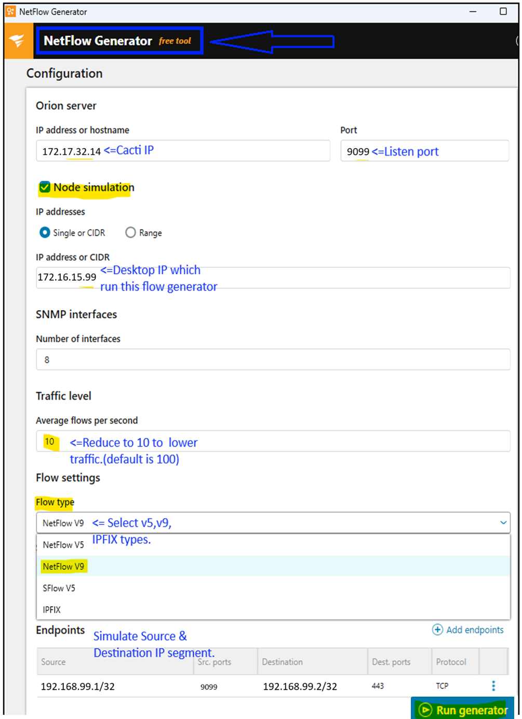

Start generating flow v9 traffics…  
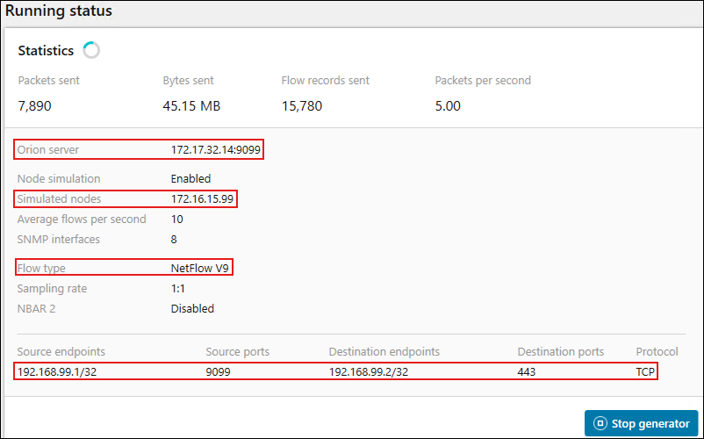

## Configure listeners

Configure folwview generator to create test flow traffic on UDP port 9995 (v5), 9996(v9, 9997(IPFIX)

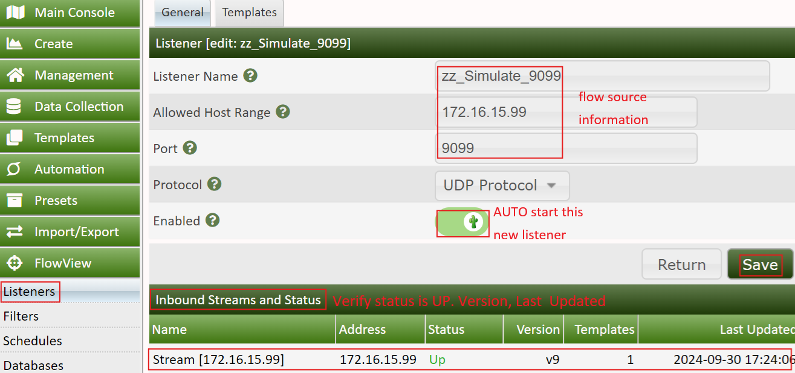

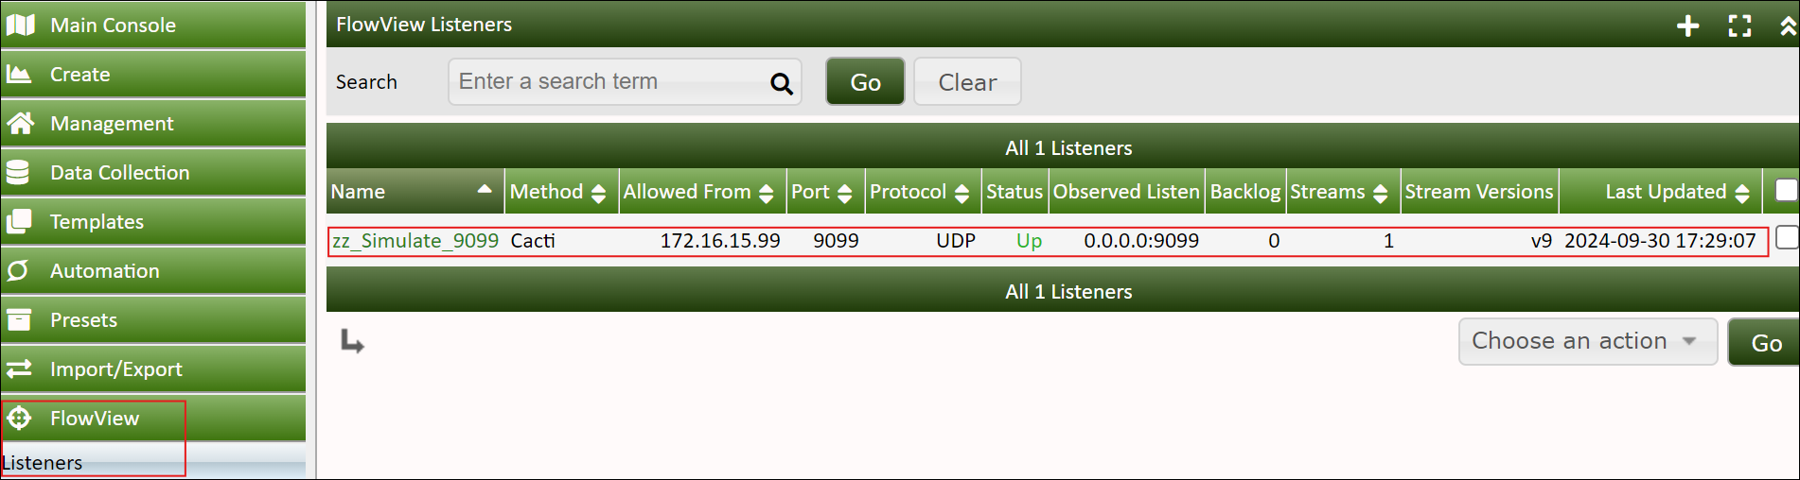

systemctl status flow-capture

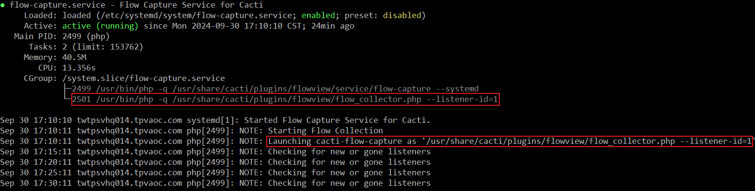

## Configure filters

Create filters map to listeners, “Stream Address” IP & Max. Row “Top 15” must be assigned to increase stability.   
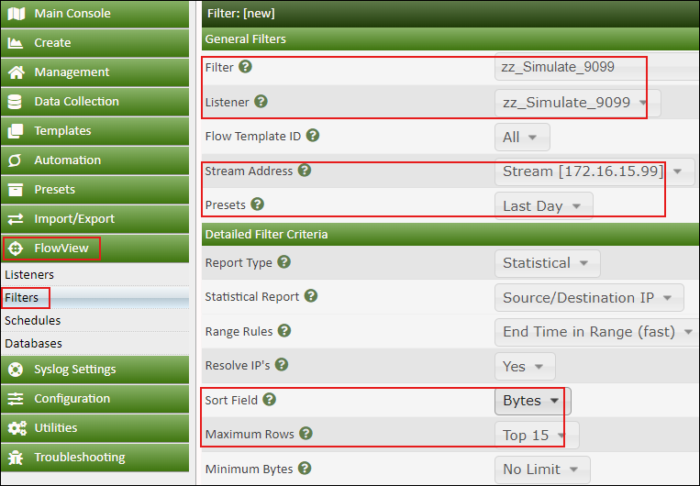  
Result of 4 filters

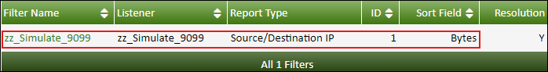

Click “FlowView” => Select Filter & Listener => Click “GO” => Click “Table”  
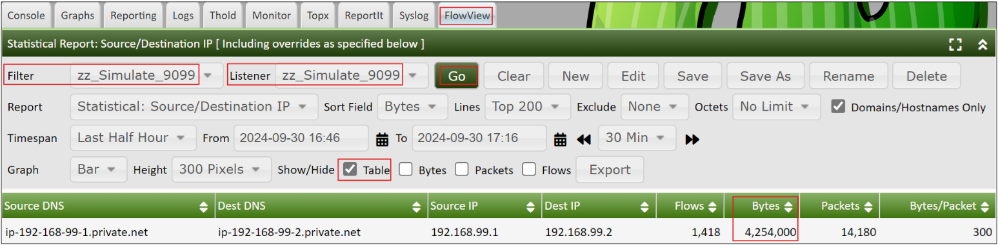

1. Show flowview DB table size & row number

#Show flowview DB table size & row number

mysql -uroot -e "SELECT t.table_name AS \`Table\`, ROUND(((t.data_length + t.index_length) / 1024 / 1024), 2) AS \`Size (MB)\`, t.table_rows AS \`Rows\` FROM information_schema.tables t WHERE t.table_schema = 'flowview' ORDER BY (t.data_length + t.index_length) DESC;"

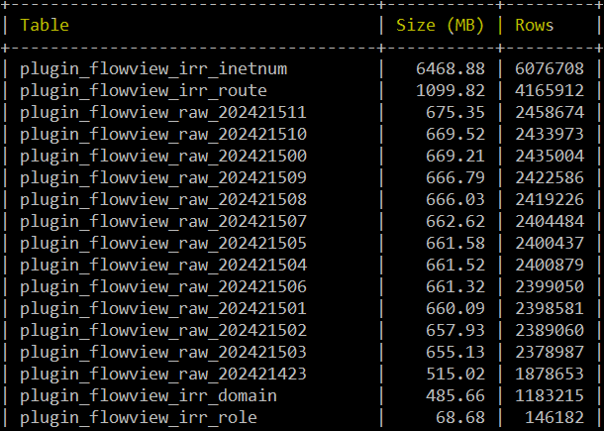

* 1. **Configure listeners**

Configure folwview generator to create test flow traffic on UDP port 9099 (v9)





systemctl status flow-capture



* 1. **Configure filters**

Create filters map to listeners, “Stream Address” IP & Max. Row “Top 15” must be assigned to increase stability.   
  
Result



* 1. **Statistical Report**

Click “FlowView” => Select Filter & Listener => Click “GO” => Click “Table”  


* 1. **Check DB size & Row numbers**

#Show flowview DB table size & row number

mysql -uroot -e "SELECT t.table_name AS \`Table\`, ROUND(((t.data_length + t.index_length) / 1024 / 1024), 2) AS \`Size (MB)\`, t.table_rows AS \`Rows\` FROM information_schema.tables t WHERE t.table_schema = 'flowview' ORDER BY (t.data_length + t.index_length) DESC;"



* 1. **Sample flow export configuration on Cisco SW & Fortigate**

***Cisco Switch:***

flow record TPV-Flow-Record

match ipv4 destination address

match ipv4 source address

match transport source-port

match transport destination-port

match ipv4 protocol

match interface input

match ipv4 tos

match flow direction

collect counter bytes long

collect counter packets long

collect transport tcp flags

collect timestamp absolute first

collect timestamp absolute last

collect interface output

!

!

flow record TPV-Flow-Record-OUT

match ipv4 destination address

match ipv4 source address

match transport source-port

match transport destination-port

match ipv4 protocol

match interface output

match ipv4 tos

match flow direction

collect counter bytes long

collect counter packets long

collect transport tcp flags

collect timestamp absolute first

collect timestamp absolute last

collect interface input

!

!

flow exporter FNFexp

destination 172.17.32.16

source Vlan99

transport udp 2055

!

!

flow exporter test

destination 172.17.32.14

source Vlan99

transport udp 2055

!

!

flow monitor FlowMonitor1

exporter FNFexp

exporter test

record TPV-Flow-Record

!

!

flow monitor FlowMonitorOUT

exporter FNFexp

exporter test

record TPV-Flow-Record-OUT

!

!

sampler sampler1

description sample at 50%

mode random 1 out-of 2

!

!

interface GigabitEthernet1/1/2

switchport trunk allowed vlan 99

switchport mode trunk

ip flow monitor FlowMonitor1 sampler sampler1 input

ip flow monitor FlowMonitorOUT sampler sampler1 output

channel-group 2 mode active

interface GigabitEthernet2/1/2

switchport trunk allowed vlan 99

switchport mode trunk

ip flow monitor FlowMonitor1 **sampler sampler1** input

ip flow monitor FlowMonitorOUT **sampler sampler1** output

channel-group 2 mode active

***Fortigate Firewall:***

FG3H1E5819903613 (global) # show system netflow

config system netflow

    set collector-ip 172.17.32.14

    set collector-port 9005

    set source-ip 172.17.32.100

    set active-flow-timeout 60

    set inactive-flow-timeout 10

end

FG3H1E5819903613 (global) # show system interface "port3"

config system interface

    edit "port3"

        set vdom "root"

        set ip 172.17.32.100 255.255.255.0

        set allowaccess ping https snmp

        set type physical

**set netflow-sampler both**

**set sflow-sampler enable**

**set sample-rate 50**

        set explicit-web-proxy enable

        set description "LAN"

        set alias "lan"

        set device-identification enable

        set role lan

        set snmp-index 5

    next

end